

promoter: Dr.Bert Wolfs

by

Sanita bērziņa

January 2019

A thesis

presented to the faculty of BA school of business and finance and SBS swiss business school

In partial fulfillment of the requirement for the degree

master of business administration in international finance and banking/

Maģistrs finansēs ar specializāciju starptaustiskajās finansēs un banku darbībā

Ieguldījums Apģērbu mazumtirdzniecības uzņēmumā latvijā

investment in retail clothing business in latvia



Ieguldījums Apģērbu mazumtirdzniecības uzņēmumā latvijā

investment in retail clothing business in latvia

presented to the faculty of BA school of business and finance and SBS swiss business school

In partial fulfillment of the requirement for the degree

master of business administration in international finance and banking/

Maģistrs finansēs ar specializāciju starptaustiskajās finansēs un banku darbībā

**Student Declaration:**

I declare that I, **Sanita Bērziņa**, the undersigned, have completed this work

and that I have not used any other than permitted reference sources or materials nor engaged in any plagiarism. All references and other sources used by me have been appropriately acknowledged in the work. I further declare that the work has not been submitted for the purpose of academic examination, either in its original or similar form, anywhere else.

_______________________________ _______________________

**Signature** Place / Date

**Promoter Declaration:**

I, the undersigned, verify that this document meets *BA* School of Business and Finance and SBS Swiss Business School academic standards.

_______________________________ _______________________

**Name, Surname, Position** Place / Date

**Reviewer’s signature (*BA* School of Business and Finance):**

_______________________________ _______________________

**(Title) First Name Last Name** Place / Date

Table of contents

List of tables iv

List of figures v

Foreword vii

Executive Summary viii

Chapter 1. Introduction 1

1.1. Background of the problem 1

1.2. Background of the study 1

Chapter 2. Objectives of the study 2

2.1. Problem statement 2

2.2. Objectives of the study 2

2.3. Hypothesis statement 2

Chapter 3. Literature review 3

3.1. Chapter introduction 3

3.2. Investment strategies and assessment methods 3

3.3. Business model 8

3.4. Retailing and retail industry 10

3.5. Market analysis: Collecting information and forecasting demand 15

3.6. Legal environment and government regulation in Latvia 17

3.7. Summary of key points 18

Chapter 4. Collection of primary data 21

4.1. Methodology 21

4.2. Research design 21

4.2.1 Type of research 21

4.2.2 Design of research instrument 21

4.2.3 Sample selection 21

4.3. Research execution 22

4.4. Analysis of data 22

4.4.1 Profile of respondents 22

4.4.2 Analysis of responses 23

Chapter 5. Analysis and conclusion 33

5.1. Hypothesis testing 33

5.1.1 Financial forecast for three years 33

5.1.2 Retail industry analysis according to the Five Forces model 41

5.1.3 PESTEL analysis for retail industry 47

5.1.4 SWOT analysis for the investment company 58

5.1.5 Business model canvas 63

5.2. Intermediate conclusions 64

Chapter 6. Conclusions and recommendations 66

6.1. Summary of findings 66

6.2. Overall conclusion 67

6.3. Recommendations 68

6.4. Lessons learned 68

6.5. Ethical implications 69

Bibliography 73

Appendices 76

# List of tables

|  |  |  |
| --- | --- | --- |
| No. | Name | Page |
| 5.1. | The SWOT analysis for the investment company | 58 |
| 5.2. | Business model canvas for the investment company | 63 |

# List of figures

|  |  |  |
| --- | --- | --- |
| No. | Name | Page |
| 4.1. | Answers from the survey about dress code at work | 23 |
| 4.2. | Answers from the survey about places for shopping workwear | 24 |
| 4.3. | Answers from the survey about choice of workwear in Latvia | 25 |
| 4.4. | Answers from the survey about most important factors for choosing workwear | 26 |
| 4.5. | Answers from the survey are quantity of clothes more important than quality | 27 |
| 4.6. | Answers from the survey is quality of fabrics important | 27 |
| 4.7. | Answers from the survey to rank the factors important for choosing custom made workwear | 28 |
| 4.8. | Answers from the survey about waiting time of custom-made clothes | 29 |
| 4.9. | Answers from the survey about options to buy custom-made clothes | 29 |
| 4.10. | Answers from the survey about best composition of the business suit for women | 30 |
| 4.11. | Answers from the survey about intention to buy custom-made clothes for work | 31 |
| 4.12. | Answers from the survey about intention to buy custom-made suit for 450 euros | 32 |
| 5.1. | Break-even point for company | 36 |
| 5.2. | The turnover projection for the first three years for three scenarios in euros | 36 |
| 5.3. | Units sold projection for the first three years for three scenarios | 37 |
| 5.4. | Gross margin (%) and Net Income in euros for the first three years for three scenarios | 38 |
| 5.5. | The average return on Investment (%) for the first three years for three scenarios | 39 |
| 5.6. | Net profit margin (%) for the first three years for three scenarios | 40 |
| 5.7. | EBITDA margin (%) for the first three years for three scenarios | 40 |
| 5.8. | The Five Force analysis for the Online retail and Apparel retail industry in Europe | 47 |
| 5.9. | Monthly household disposable income in euro in Latvia from 2006-2016 | 50 |
| 5.10. | Household consumption expenditure structure (%) from 2006-2016 | 51 |
| 5.11. | Average gross monthly salary by kind of activity from 2007-2017, in euros | 52 |
| 5.12. | Annual average number of employees by monthly gross income in euros and age group in 2017 | 55 |
| 5.13. | Annual average number of employees by monthly gross income in euros and gender in 2017 | 56 |

# Foreword

I would like to thank Dr. Bert Wolfs for challenging me and giving valuable, constructive feedback. My thanks to all survey respondents for their time spent on filling survey.

A gratitude goes to my workplace AS 4finance and my direct manager Aldis Paegle for finding time during busy schedule and giving support to me to finish thesis.

Special thanks goes to my husband for being main motivator for me during all study process.

# Executive Summary

Retail clothing industry in Latvia has few main shopping centers offering the same brands, although the industry is developing for which main signs are an expansion of main shopping centers and the opening of new ones in 2019. However, fast fashion brands offer low quality stylish clothing mostly casual wear. There is a very weak offer of formal and business casual style clothing in high quality for women.

This thesis looks at investment in the retail clothing business in Latvia and valuates if new clothing line for women will be profitable. In order to reach the above target, four objectives of the study were set for this thesis:

1. To learn what investment strategies are most appropriate for small companies, what is a business model and how to use it, what is retailing and what are main typicality’s for the retail industry, how to collect information and forecast demand in the market and analyze the legal environment in Latvia.
2. To research whether there is demand for a new clothing line in Latvia.
3. To forecast and analyze financial data and observe if investment in retail clothing business will give returns.
4. To work out conclusions and develop recommendations regarding investment in the retail clothing business in Latvia.

The study of the literature revealed that most common investment strategy in a small company is bootstrapping, and analysis of industry and main drivers that impact its profitability should be evaluated. Business model development of a company helps to build the strategy and can be done using business model canvas.

Market research for primary data showed demand for a new clothing line and revealed customer desire for high - quality workwear with unique designs.

For secondary research, the author performed retail industry analysis and financial projections for a three-year period for three different scenarios.

Based on primary research and secondary research, the author is rejecting the Null hypothesis while accepting the Alternative hypothesis, as the introduction of a new clothing line in Latvia will generate profit in first two years based on all three financial scenarios projected.

# Introduction

## Background of the problem

Medium - sized and large companies with corporate culture usually have a dress code for work which employees should comply with. This usually is business casual or formal. Latvia’s retail industry consists mainly of few big shopping centers all of them offering the same brands for customers. Business casual and formal wear offer are very weak in retail stores and most of brands are fast fashion brands with low quality. The market niche for high-quality business suits for women is empty. The retail industry has seen growth in few recent years and economic projection for Latvia are moderate in next years, disposable income for households are increasing and consumer confidence remains positive. There are possibilities to fulfill the demand for high-quality workwear for women in the retail market in Latvia.

## Background of the study

In order to learn if investment in the retail clothing business in Latvia will give positive returns the author of this thesis has used various research methods.

Chapter 3 is based on non-empirical research method – a literature review. The chapter focuses on investment strategies, business models, retailing and retail industry specifics, forecasting methods for market demand, legal and governmental environment review of Latvia.

Chapter 4, which is dedicated to the collection of primary data, the author conducted the survey as a questionnaire to understand if clothing line will have demand and analyzed results.

Chapter 5 in this thesis is dedicated to hypothesis testing, the author uses quantitative and analytical methods and studies weather investment in new clothing line will generate profits in the first two years. Part of most interesting findings is portrayed using a graphical method.

# Objectives of the study

## Problem statement

The problem discussed in this study is whether investment in the new company offering high-quality workwear for women gives returns in Latvian retail market. The topicality of the problem is given for several reasons. Firstly, there is a weak offer of business suits for women in Latvia retail shops. Secondly, despite the most popular shopping centers expand and the market will enter also new ones, offered brands remain mainly the same in all of them. Thirdly, mostly all offered brands are fast fashion with low quality and the high-quality garments are lacking from retail stores. Finally, the retail sector is growing and gross salaries also which means households have a more disposable income to buy goods.

## Objectives of the study

Here below are the objectives of this study:

1. To learn what investment strategies are most appropriate for small companies, what is a business model and how to use it, what is retailing and what are main typicality’s for the retail industry, how to collect information and forecast demand in the market and analyze the legal environment in Latvia.
2. To research whether there is demand for a new clothing line in Latvia
3. To forecast and analyze financial data and observe if investment in the retail clothing business will give returns.
4. To work out conclusions and develop recommendations regarding investment in retail clothing business in Latvia

## Hypothesis statement

For purpose of this study the author has proposed two hypotheses:

* H0: the introduction of a new clothing line for women in Latvia, will not generate a profit in the first two years.
* Ha: the introduction of a new clothing line for women in Latvia will generate a profit in the first two years.

# Literature review

## Chapter introduction

This chapter consists of the comprehensive review of existing documentation and research of small business creation in Latvia, investment strategies, retail industry analysis, business model, marketing strategy and forecast demand. Review of Legal environment and government regulation is done.

## Investment strategies and assessment methods

Investment in new business is usually the first question each entrepreneur has in mind. Without proper financing, there is a very weak option to start successfully. There are different types of investment new company can look at, however, it is important to understand how big investment is necessary and is it possible to get in from internal sources or external.

The study of investment strategies emphasizes the importance of choosing the right option for investment:

* Choosing the right sources of capital for a business can be just as important as choosing the right form of ownership or the right location. It is a decision that will influence a company for a lifetime; therefore, entrepreneurs must weigh their options carefully and understand the consequences of the deal before committing to a funding source
* The money is out there; the key is knowing where to look. Entrepreneurs must do their homework before they set out to raise money for their ventures. Understanding which sources of funding are best suited for the various stages of a company’s growth and then taking the time to learn how those sources work is essential to success
* Creativity counts. To find the financing their businesses demand, entrepreneurs must use as much creativity in attracting financing as they did in generating the ideas for their products and services
* The Internet puts vast resources of information that can lead to financing at entrepreneurs’ fingertips. The Internet often offers entrepreneurs, especially those looking for relatively small amounts of money, the opportunity to discover sources of funds that they otherwise might miss. The Internet also provides a low-cost, convenient way for entrepreneurs to get their business plans into potential investors’ hands anywhere in the world. When searching for sources of capital, entrepreneurs must not overlook this valuable tool!
* Be thoroughly prepared before approaching potential lenders and investors.
* Looking for “smart” money is more important than looking for “easy” money. Some entrepreneurs have little difficulty attracting investors’ money. However, easy money is not always smart money. Even though it may be easy to acquire, money from the wrong investor can spell disaster for a small company. Entrepreneurs cannot overestimate the importance of making sure that the “chemistry” among themselves, their companies, and their funding sources is a good one
* Plan an exit strategy. Although it may seem peculiar for entrepreneurs to plan an exit strategy for investors when they are seeking capital to start their businesses, doing so increases their chances of closing a deal. Investors do not put their money into a business with the intent of leaving it there indefinitely. (Scarborough, 2012, p. 452)

Continuing the same study (Scarborough, 2012) has identified capital as a form of wealth employed to increase this wealth more. There are three types of capital: fixed, working and growth capital and all of them are important to the business. For new business, most likely possible sources of money are personal savings, friends and relatives, angel investors and partners.

Equity capital and Debt capital has been analyzed more deeply (Scarborough, 2012). Equity capital is an investment made in a company by owner or owners. There is risk related with invested money as if the business fails, there is a risk of losing this investment. The benefit of this capital is that there is no necessity to repay it as it is in debt capital. The main disadvantage is in case of external investor investment, owner of the company loses its ownership in the business.

Scarborough (2012) described the main sources of equity capital:

* Personal savings
* Friends and family members
* Angels
* Partners
* Corporate Venture Capital
* Venture Capital Companies
* Public Stock Sale
* Foreign Stock Markets

Personal savings as one of equity capital sources will be looked at more closely as it is more relevant for small business. Of course, the industry, where business will operate, will also impact the amount of investment it will need. Personal saving usage for main investment in a company is also known as bootstrapping.

Advantages of using bootstrapping for new business have been realized a few decades ago (Bhide, 1992). The study shows that most new businesses start with pursuing niche markets that are too small to interest large competitors or venture capitalist companies. Bhide (1992, p. 112) defines “bootstrapping in a start-up is like zero inventory in a just- in-time system: it reveals hidden problems and forces company to solve them.”

Reviewing the study (Bhide, 1992), it unfolds the examples of companies attracted external funding at an early stage and made mistakes which could be avoided if money were less and tracked more carefully. Another consequence of the new company which at early stage got funding is diminished flexibility.

Starting a new business with limited funds means different approach and mindset, and strategy will differ from well-capitalized new business. There is also copycat strategy as an option for bootstrappers as it allows to save costs on market research and competition is not so harsh from big large companies. Strategies can be changed if necessary, as quick break-even and cash-generating a project are crucial. Bootstrapped new business does not have a huge marketing budget, so high-ticket products and services that can sustain direct personal selling should be offered (Bhide, 1992, p. 114).

New business with such funding usually has an owner and the same person manager. The employees usually are new enthusiasts who join to gain opportunities and upgrade skills. Bootstrappers expand at the rate they can afford and control, it is financially prudent and develops management skills also. Keeping a focus on positive cash flow and not on profit or market share is a way to work. New business option to get a loan from the bank is usually very low, but bank loans can be a cheaper alternative to external equity and necessary for growth funding later or. It is advisable to cultivate banks before a new business becomes creditworthy (Bhide, 1992).

Investment assessment methods are crucial when choosing one or other from possibilities of different investing options.

Taking decision to invest takes a lot of bravery of decision - making person, information availability about range of issues should be known: for example, the market environment, level of demand for respective activity, internal environment, culture, capabilities of company, types, and levels of cost elements for proposed area of activity and understanding the risk appertaining to the project. (Arnold, 2013, p. 51)

The same study by Arnold (2013, pp. 51-52) emphasis employment of an investment appraisal technique which leads to correct decision; “a technique which considers fundamental considerations.” There are four techniques for evaluating investments the in company. Net present value (NPV) and internal rate of return (IRR) emphasize the importance of the concept of the time value of money and are described as discounted cash flow (DCF) techniques (Arnold, 2013). These are most commonly used techniques also in large corporations. The study states that the first two mentioned techniques are more complete than the other two: payback and accounting rate of return (Arnold, 2013). The objective of investment is to create value for its owners and purpose of allocation money to project is to generate cash flows in the future which will bring back more than initially invested. The study suggests take decisions for investing looking at decision inputs, such as cash flow and the time value of money, prepare decision analysis using discounted cash flow techniques and after take a decision (Arnold, 2013).

A different study states investment selection from another point of view.

Most criteria used for the selection of investment are based on rationality that seeks only profitability and recovery of investment; however, in an uncertain environment, external constraints influence decision to invest and sometimes forces agents to focus on other strategic and survival concerns of the companies to the detriment of the unique optimization of the profit and of the recovery over time of the financial resources committed. (Apostol, 2015, p. 131)

The same study shows that regardless of the method used in the valuation of investment, its usually wise to investigate all alternatives and decide by comparing (Apostol, 2015).

The basic idea of net present value is that investment should be made only if there will be positive net present value and if choosing from more than one, the investment with highest net present value should be chosen. It is calculated as a difference between present project value and cost of the investment project. The discount equals bringing in the present the future cash flow spread over the investment project completion period (Apostol, 2015). The study suggests choosing the interest rate of the money market as a discount rate because it is the same rate investor could get back if lending in the money market (Apostol, 2015).

The internal rate of return can be viewed as a discount rate at which the net present value is zero. To calculate this cash flows and their precise timing should be known (Arnold, 2013). The internal rate of return decision rule is simple: if the opportunity cost of capital is greater than the internal rate of return then better not to invest.

This method cannot be used if cash flows are only negative for a whole period.

The study suggests if the only purpose for decision-maker is maximizing profit, it is not enough to have an internal rate of return higher than a discount rate, as an internal rate of return should exceed threshold limit, namely economic rate of return of the company which is equivalent to the weighted average cost of capital. (Apostol, 2015, p. 134)

The payback time criterion the investment alternatives will be selected depending on how fast invested capital can be recovered. The time required to recover the investment cost expresses the number of years of recovery through average annual cash flows discounted. A decision should be made for investment which payback time is minimum and at the same time shorter than investment lifespan. Thus, rapidity of getting back investment do not show a quality of project invested, and it is not visible what happened beyond the minimum capital payback time. The disadvantage is that this method eliminated project of good internal rate of return in the long term (Apostol, 2015).

According to Apostol (2015) “accounting rate of return looks at projected income and expense of new investments and comparing the ratios between future gains and total operating costs incurred” (p. 134) and this method could be used only if there are enough and credible annual average forecasts available, otherwise the results may not show full picture.

Study emphasizes “the ever-increasing instability and competitiveness of the business environment change the forecast evolution of activity and profitability, and the high level of inertia of a productive investment project is a major characteristic that can hardly be ignored ” (Apostol, 2015, p. 136).

## Business model

This subchapter describes a business model and its usage of clear guidance when starting the business.

“A business model describes the rationale of how an organization creates, delivers and captures value” (Osterwalder & Pigneur, 2010, p. 14).

Other authors describe importance to look at business models more deeply.

New business face difficulties, including a high-level uncertainty regarding the market and other aspects of the business model; lack of knowledge about challenges in areas such as law, technology, marketing, and finance; also, difficulties related to professionalizing administrative process, and trouble attracting enough human and finance capital. (Garcia-Gutierrez & Martinez-Borreguero, 2016, p. 2)

The same study looks at different existing business models and compares each other, describing different approaches (Garcia-Gutierrez & Martinez-Borreguero, 2016). New business activities will differ from well-established business activities, it will be reflected also in a business model. In the Lean Startup model established in 2011 by Eric Ries uncertainty that entrepreneurs face is reduced involving them in a validated learning process, frequent testing of market-based experiments which was included in their initial vision of the business. Basically, a method is based on activity build-measure-learn and after taking decisions for change approach or stay with existing. Another model for review was taken customer development model developed by Blank and Dorf. This model is based on key business model hypothesis testing in four steps for pricing, markets, customers and channels, after corrections in a model is done before another round of testing. Next one analyzed is Business Model Canvas designed by Osterwalder and Pigneur. It represents a business model in nine blocks presented in a simple way. Business Model Canvas is most popular of business models, thus amongst advantages of user-friendly approach, facilitating interaction among shareholders and providing support for continuous improvement, it omits critical aspects of business model design – business strategy and competitive environment. For innovators, they advise to complete analysis using different tools. A business model focused on new business related to innovation are developed by Bill Aulet. The model developed as a 24-step framework to guide entrepreneurial projects for small and medium enterprises and innovation-driven enterprises. Model includes all aspects of business definition – value proposition to channels, target customers, product definition, monetizing strategy, business scale. This is for enterprises that will serve the local market and possibly grow until the medium size and for ones intended to grow a regional or global level and is riskier.

For purpose of this study closer review will be done for Business Model Canvas created by Osterwalder and Pigneur, as its most commonly used and new business will not be innovation-driven enterprise.

According to the study Business Model Canvas consists of nine blocks showing the steps of how an enterprise will make money (Osterwalder & Pigneur, 2010). The canvas looks through four main areas of each business which are customers, infrastructure, offers, and financial possibilities. Nine building blocks of Business Model Canvas are described further in more details.

The first block is Customer Segments. Most important for this block is to understand which segment company will serve and which ignored. After defining this, strong understanding of specific customer needs should be designed.

The second block is Value Propositions. This is a reason why the customer chose a company and its products. Values can be quantitative or qualitative. It solves the problem or satisfies customer need. In this block, a company defines benefits that will be offered to customers.

The third block is Channels. This is a way how a company communicates and reaches its customer to deliver Value Proposition. The right mix of channels is important for bringing successfully Value Proposition to market. Channel types are own and partner. Own can be direct such as own store or website or indirect – store operated by other organization. Partner channels can be indirect as partner stores and wholesaler.

The fourth block is Customer Relationships. These can be personal and automated. Overall customer experience can be influenced based on how its set-in business model. Customer Relationships has several categories: Personal assistance, Dedicated personal assistance, Self-Service, Automated services, Communities, Co-creation.

The fifth block is Revenue Streams. There could be two types of Revenue Streams – transaction revenues and recurring revenues. This block also analysis more deeply ways to generate revenues and looks at different pricing mechanisms.

The sixth block is Key Resources. Here are identified most important assets for a business model to work. Key Resources can be categorized as physical, human, intellectual and financial.

The seventh block is Key Activities. These are production, problem-solving, platform/network.

Eight block is Key Partnerships. This is a network of suppliers and partners that could make business model work. Partnerships can be divided as strategic - alliances between non-competitors, the same between competitors, joint ventures and buyer -supplier relationships.

The ninth block is Cost Structure. Here are identified the most important costs for the business model. In the business model, there could be cost-driven and value-driven Cost Structure. Cost Structures has fixed costs, variable costs, economies of scale and economies of scope.

## Retailing and retail industry

“Retail industry is one of the biggest industries in the world. It is vital to the development of every country’s economy in terms of its contribution to the economy and positive effects on employment” (Ersoy, 2017, p. 539).

The recent study of Japee (2016) describes retailing as “final step in the distribution of merchandise the last link in the supply chain connecting the bulk producers of commodities to the final consumers” (p. 11) and retailer is final stock point who makes products and services available to the consumer. The value proposition of retailer: get the desired product or service at the desired place, time and size. In developed countries, the retail industry has become a full-fledged industry where only 1/3 from total retail trade is not done by organized sector (Japee, 2016). The retail segment is organized in two segments, first is In-store retailers who operate in fixed locations and attract high-volume walk-in customers; second is non-store retailers who reach out to the customer homes and offices.

The study lists major formats of in-store retailing:

* Branded stores – exclusive showrooms as a franchise or owned, a value proposition is available full range of defined brand and certified product quality;
* Specialty stores – focus on a specific need of the customer, offers most of the brands, a value proposition is more choice, a comparison between different brands is available;
* Department stores – large store, huge variety, offer food, clothing, housewares, a value proposition is one stop shop.
* Supermarkets – extremely large self-service retail outlet, a value proposition is one stop shop as in department stores;
* Discount stores – offering discounts from retail price through selling large volumes, a value proposition is a low price;
* Hypermart – larger than a supermarket, could be with warehouse appearance, usually, in a quiet part of the city, a value proposition is low prices and vast choice;
* Convenience stores – small self-service stores in crowded areas in a city, a value proposition is long working hours and convenient location;
* Shopping malls – different formats on in-store retailers under one roof, value proposition is variety of shops (Japee, 2016).

Retailing growth factors are increasing population, increased per capita spending, dual-income families, thus convenience and speed of service for this factor have become crucial paraments due to the limited time of shopping; urbanization and option of covering distances for shopping in desired place (Japee, 2016).

In the past decade new concept has developed in retail – Lifestyle Retailing, the growth sector of tomorrow (Japee, 2016). “Retail industry has become more organized and it has driven the customer need to shop from spaces that are more in keeping with their lifestyle needs” (Japee, 2016, p. 39). More emphasis has been put on how stores look, what are product presentation, packaging, enhanced customer service. The study describes lifestyle retailing as retail stores dealing with ready-to-wear garments for women and men, jewelry, footwear, cosmetics, products for kids, toys and all this under one roof (Japee, 2016).

Information availability nowadays provides huge amounts of data to analyze customers. Report on the global fashion industry published by the company The Business of Fashion in cooperation with management consulting company McKinsey & Company states that key trend for year 2018 is the personalization of fashion (The Business of Fashion and McKinsey & Company, 2018). The report includes extensive qualitative and quantitative analysis, including data from 500 fashion companies and interviews of 200 senior fashion executives. Based report the personalization of fashion is the number one trend in 2018. Consumer shifts towards getting personal are described in the report “as consumer values coalesce around authenticity and individuality, brands will evaluate data even more to tailor recommendations, engage influencers and personalize experiences” (The Business of Fashion and McKinsey & Company, 2018, p. 26). Personalization of fashion means more-customize products, curated recommendations, communication and storytelling that connects to individuals. Customers expect personalization from online business. The main driver for this trend is customer wish to use their fashion choices to express individual style, self-image, and values. The use of social media increases this trend. The customer way of thinking is described such way as “costumers prefer brands that align with their own values and seek authenticity from fashion companies they engage with, they want business with purpose and product has to be A-plus bit it is also really what they stand for and believe in” (The Business of Fashion and McKinsey & Company, 2018, p. 44) . This means that fashion companies need to change the way they communicate with customers. There is a trend of customer becoming pickier, which drives to increase for unconventional and signature items, and products with higher quality, better prices, and exclusive and authentic. More people are looking for niche brands. Customers are using new sources to help them manage their product selection. They are more trusting other customers reviews and experience, perceive the lifestyle of influencers they follow. As an answer to this, companies will start to use more data for analysis to tailor the offers. There are already good examples of companies which captured this trend and created a successful business such as Stitch Fix which serves personal stylist using an algorithm to deliver personalized packages to customers (The Business of Fashion and McKinsey & Company, 2018).

Understanding of industry itself is crucial to benefit from, thus Michael E. Porter propose to look at five different forces which impact industry’s profitability and allows each entrepreneur using this analysis make right steps when considering new entry in the market.

Harvard Business Review (2008) summarized M.E. Porter’s study The Five Competitive Forces that Shape Strategy where emphasized narrow looking at competition form managers. “Competition is not only direct competitors in the market, but competition includes other forces: customers, suppliers, substitute products and new entrants. The extended rivalry that results from all five forces defines an industry’s structure and shapes the nature of competitive interaction within an industry” (Harward Business Review, 2008, p. 79).

The study shows that despite the different characteristics of industries the main drivers for profitability are the same in all of them and to choose a proper strategy for a company entering the industry, it should analyze underlying structure in terms of these forces. If forces are intense, almost no company earns desired returns on investment, if forces are fine, many companies are profitable. To understand the industry’s current profitability and what factors influence profitability and competition, the study of five forces are necessary (Harward Business Review, 2008).

The same study defines forces more detailed.

Forces that shape competition in the industry are rivalry among existing competitors, the threat of new entrants, bargaining power of buyers, the threat of substitute products or services and bargaining power of suppliers. The strongest competitive force or forces determine the profitability of an industry and are the most important when formulize strategy of the company. (Harward Business Review, 2008, p. 80)

The threat of entry means new entrants in industry desiring for market share. This means pressure on prices, costs, and possible investments. Industry can have entry barriers which should be validated. There are 7 major sources of barriers to entry:

1. Supply - side economies of scale – existing companies producing large volumes benefit from a lower cost per unit, entering this market entrant should understand that there will be cost disadvantage.
2. Demand - side benefits of scale – benefits arise when a buyer is willing to pay for company product more if a number of other customers like the same product. Buyers may trust larger companies for an important and expensive product more. New entrants risk as in such industry there could be few customers that want to buy from a newcomer.
3. Customer switching costs – these are fixed costs customer may face when changing suppliers, mostly related to information systems.
4. Capital requirements – there are industries which require large investments to properly compete with existing companies. The barrier of entry is even harder to face if capital is for unrecoverable expenditures, which are harder to finance.
5. Incumbency advantages independent of size – existing companies can have cost or quality advantages that are not available to new entrants. This could be existing agreement with suppliers, favorable locations, brand identities, and experience.
6. Unequal access to distribution channels – this should be evaluated very carefully, as in some industries there could be even necessary for a new entrant to create own distribution channel due to a high barrier.
7. Restrictive government policy – these could be licensing requirements or restrictions of foreign investments. There could be also some patenting rules which make entry difficult. The government can make entry also easier by subsidies or funding basic research (Harward Business Review, 2008).

Powerful suppliers in the industry can squeeze out profitability by rising prices or reducing quality. Power of suppliers depends on a number of characteristics of its market situation and the importance of its sales or purchases to the industry if compared with its overall business (Harward Business Review, 2008).

“Power of buyers is their possibility to force down prices, ask for better quality or additional service. Buyers are powerful if they have negotiation leverage relative to industry participants” (Harward Business Review, 2008, p. 83).

The threat of substitutes could be downstream or indirect. If the threat of substitute is high, industry profitability can decrease, this could impact also industry growth level. Changes in other industries should be constantly looked at, to identify possible substitutes that were not there before.

Rivalry among existing competitors can take a form of price discounting, new product introductions, marketing campaigns, and even service improvements. The same as other forces, it can bring down industry’s profitability. The intensity of rivalry is highest if there are many and equal sizes and power competitors in the industry, there are high exit barriers, competitors are with high commitment to business.

In a study also described that analyzing the structure of the industry, keeping in mind five forces, helps an entrepreneur to stay focus on structure conditions avoiding focusing on fleeting factors. When looking at entering the industry, some visible factors should be validated. These could be the industry growth rate, which not always makes the industry profitable. Technology and innovations in the industry do not necessarily make industry attractive or vice versa. Government influence should be analyzed based on how its policies influence five competitive forces. Complimentary products and services affect industry’s profitability through the way they influence five forces (Harward Business Review, 2008).

There are suggested for industry analysis in practice, firstly understanding the appropriate time horizon for industry analysis, for the most industries time horizon of 3 to 5 years is sufficient. Secondly, to evaluate profitability for the industry, a quantitative measure should be analyzed, industry’s participants’ income statements and balance sheets capture main information for margins, research and development costs, inventory amounts. Thirdly, understanding which forces underpinning today’s profitability of industry is (Harward Business Review, 2008).

## Market analysis: Collecting information and forecasting demand

Review of the importance of proper market research and customer surveys for forecasting demand

A new business which has plans to entry market should evaluate possible demand for products or services it will offer. This will later foster proper financial plan preparation and necessary investment amount determination. Forecasting demand is closely related to marketing research.

Detailed study emphasizes the necessity to understand the marketing environment and manage marketing research as it helps to identify marketing opportunities (Kotler & Keller, 2016). The same study reveals the importance of measuring and forecasting the size, growth, and profit of each market opportunity.

The sales forecasts are afterward used in planning projected financial statements and measuring revenues and potential investment necessary for new business. The market forecast should be precise as otherwise there could be wrong decision making by managers. To be precise marketing responsible persons should define what they mean with market demand. (Kotler & Keller, 2016, p. 107)

The same study also reveals the marketing demand substance.

Market demand for the product is the total volume that would be bought by a defined customer group in a defined geographical area in defined time in defined marketing environment under a defined marketing program. (Kotler & Keller, 2016, p. 109)

Marketing demand is not fixed numbers but rather a function with marketing expenditure levels at the given time and resulting demand level. There could be base sales which will happen without any demand-stimulating marketing expenditures and higher marketing expenses could yield to higher demand until some point. At some certain level marketing expenditures would not stimulate further growth of demand anymore (Kotler & Keller, 2016).

In process of market demand forecast, it is necessary to understand what actual industry sales are taking place in the desirable market. This will allow to identify and analyze competitors and possibly estimate their sales. Information could be looked at industry trade associations, national statistics, and marketing research companies (Kotler & Keller, 2016).

Forecasting by Kotler & Keller is defined (2016) as “art of anticipating what buyers are likely to do under a given set of conditions” (p. 114) and for estimation of future demand, companies prepare macroeconomic forecast firstly, secondly industry forecast and thirdly based on two previous company sales forecasts. The sales forecast is made based on assumption that company will win market share. Forecasts usually are built on one of three information bases, first is what people say, second is what people do and third is what people have done. For first information base usually is used buyer surveys, for a second – putting a product into test market and look at responses, for the third one is used available companies records of past buying behavior (Kotler & Keller, 2016).

Marketing research is all about getting a more deeper understanding of marketing opportunities and problems, generate and evaluate marketing actions, monitor its performance. Marketing research is not an option only for large companies but also for small and medium ones, as there are multiple ways of conduct it with limited resources. Company can use students and professors to carry out projects; use the internet to see competitors web pages, read blogs and review sites; actually checking out rivals going to visit their stores, restaurants; use marketing firms or other marketing partners, or use employees as they have direct contact with customers (Kotler & Keller, 2016).

The study suggests six steps of conducting marketing research (Kotler & Keller, 2016). First is define the problem. The decision alternatives and the objectives of this research – definitions should be specific, not very broadly or too narrowly defined as it will impact the results.

The second step is developing the research plan – understand the data sources, research approach, instruments and sampling plan, contact methods. The data source can be primary data which company gathered especially for this research or secondary data is data which already exists and can be analyzed and measured. Research approach defines the way how to collect data. It could be observation, focus group, survey, behavioral data or even experiment. Research instruments for collecting primary data just three: questionnaire, which is most commonly used to collect the data, qualitative measures and technological devices. Sampling plan in the second step is understanding who ask questions, how many respondents are necessary and how to choose respondents. Contact methods could be mail contacts, telephone, personal and online.

The third step of conducting marketing research is collect the information. This step usually is the most expensive and error-prone.

The fourth step is analyzing the information and the fifth step is present the findings. The sixth step is decision making based on results gathered and analyzed.

Marketing research can be used for forecasting market demand for new business products or services as the information for historical sales is not existing and together with industry analysis, this could build up first sales forecast.

## Legal environment and government regulation in Latvia

Under the Commercial Law in Latvia, there are allowed several types of legal entities. Most commonly used is Limited Liability Company, Individual Merchant, Joint-stock Company, Partnership, and Branch or Representative Office. These all should be registered in the Register of Enterprises and a certain set of documentation should be submitted, which is described in the Commercial Law (Legal Acts of Republic of Latvia, 2018). Registration duty depends on the chosen form of business, the Register of Enterprises undertakes the review of applications and register companies within one to three days (The Register of Enterprises, 2018).

Limited liability company should register with a share capital of EUR 2 800. There are exceptions for small capital input in case there are not more than five individuals working, they should also be founders of a company and in company board. At end of each financial year, a company creates a reserve of 25% of financial year profit. The smallest share capital of such entity is 1 euro (Legal Acts of Republic of Latvia, 2018).

General principles of taxation determine The Taxes and Duties Act, specific taxes are assessed according to one of the specific tax laws. There are 16 state taxes, main taxes are Corporate income tax (20%), Personal income tax (20%, 23%, and 31.4%), Employers social tax (24.09%), Employee social tax (11%), and Value added tax (21%). In 2017, a separate law was introduced for startup companies. These state aid programs are determined by this law:

* A fixed social tax charge with employee’s consent;
* A supporting program for attracting highly qualified workers;
* A corporate income tax credit and a corporate income tax rebate (Investment and Development Agency of Latvia, 2018).

Investment and Development Agency of Latvia compiles the main information about investment options in the country and describes the different industries. Latvia’s external trade and customs policy is based on free trade principles. Latvia is a member of European Union since 2004, member of Schengen and active participant of World Trade Organization and Organization for Economic Co-operation and Development (Investment and Development Agency of Latvia, 2018).

## Summary of key points

There are different investment methods that can be used when financing the business. Nowadays it is very popular to use personal funding also called bootstrapping, which means that there are no external partners who invest in the company. Bootstrapping is commonly used for financing small companies with one owner of a family business. Before searching ways of funding company, the owner should evaluate the necessity of it because having somebody externally investing in capital for returns also means decision making agreeing on steps which sometimes does not comply with each other. Literature show cases when proper and more careful steps of spending money would be taken if money was self-invested not externally funded.

Main investment assessment methods are four, Net present value and Internal rate of return used more commonly and advised as most appropriate one based on studies. Nevertheless, each investment should be assessed individually, and comparisons in between should be done carefully, as companies differ from strategy point of view and market they operate.

Business models help to build a strategy for companies, Business model canvas developed by Osterwalder and Pingeur (2010) gives brief look at business model putting all main strategy points on one page. Business model canvas defines main key resources of the company, revenue streams, key suppliers, distribution chains, sales channels, communication with the customer, customer relationships and value proposition.

Retailing and retail industry is developing rapidly and expected to grow even more in the next five-year period. Online retail growing very fast and offline sales channels lacking technology touch. Despite the online retail expansion, worldwide big brand names have been valued as secure places to purchase goods, still, consumers are afraid to use unknown or poor known online stores for secure purchases. Based on MarketLine research (2018) there are signs that offline sales channels remain popular however technology touch should be added to bring value to a customer. Consumer trends change due to possibilities to move faster, customers value time and often choose shopping places where all necessary household purchases can be made in one place. This has driven the expansion of previously only grocery stores, right now offering also clothes, footwear, and household goods at one place. Lifestyle retailing has become important putting an emphasis on lifestyle consumer has. This trend put the effort on how shops look, what concepts do they have, what goods they offer. This trend has also driven a few new style developments, such as plus-size, petite, maternity.

Retail industry analysts describe the forces which impact competition and explains how important is to do proper analysis before entering the industry. Five Force model described describes factors driving competition in industry: supplier power, buyer power, a degree of rivalry, the threat of substitutes and new entrants. All these factors are valued and scaled to arrive at the description of the industry.

Forecasting market demand is a crucial part before financial projections. There are various methods to forecasting market demand, thus researchers should clearly define the objective, the process, and plan for a market study to arrive at most trustable primary data. For Secondary data usage for market demand forecasting, proper and trustable statistics should be obtained which for some small markets are not available.

Legal environment and government regulation play a big role for companies operating in the respective country. For Latvia in recent years government have made easier access to foundation of companies and applied some tax reliefs for certain part of company structures. The legal environment still has increasing minimum wages and high social taxes and value-added, corporate income tax rates that put tax burdens over companies.

# Collection of primary data

## Methodology

In order to reach the objectives of the study to understand if investment in the retail business in Latvia will bring profit after the first two years, quantitative data analysis was chosen. The Author has prepared a survey and distributed to respondents. The results have been examined and displayed using a graphical method.

In addition, financial calculations were made for the first three years of the startup company and have been analyzed using quantitative data analysis.

## Research design

### Type of research

The author decided to prepare customer survey as questionnaire including demographic questions, closed-end questions and open - ended questions. It is designed as an anonymous online questionnaire.

### Design of research instrument

A questionnaire consisted of seventeen questions, first four was demographic to understand the age, income, education, and workplace for respondents. Eight close-end questions gather main statistical information of respondents and five open-ended questions gather information from respondents where freedom of the choice answer can be delivered. Close-end questions gathered answers for such viewpoint of respondents as what dress code is at work, ranking importance of factors of choosing workwear, also questions about an intention to buy and price of the product. For closed-end questions used Liker scale type of questions, Importance scale, rating scale, and intention-to-buy scale. For full questionnaire see Appendix 2.

### Sample selection

Sample selection was made according to the investment company’s main target market – women at age 20 to 59 with a monthly gross salary above 1500 euros, working in medium and large public and private companies in Latvia. To gather at least 30 returns 90 questionnaires were distributed to respondents that comply with the target market, received filled 80 questionnaires.

## Research execution

The survey designed as online based in kwiksurveys.com and shared using email, social network, and different messengers. Kwiksurveys.com comparability with desktop, tablets and mobile phones made respondents replay rate quick. The survey distributed on 4 December 2018 and closed 24 December 2018 having 80 fully responded questionnaires.

## Analysis of data

### Profile of respondents

Almost half or 46% of respondents are women at age 30 to 34, the next biggest group 23% is age 25 to 29 and the third biggest group 14% is at age 35 to 39. There are very few respondents at age 20 to 24, 45 to 49 and 50 to 54, there is none respondents above age 55.

There are 46% of respondents with a bachelor’s degree and the same amount with master’s degree, this is the main composition of the education level of respondents. There are very few with unfinished higher education or college education.

The main part of respondents works in the private sector, its 81% or 65 respondents, remaining part work in the public sector.

More than half 57% of respondents have monthly gross salary from 1500 to 2000 euros, the next biggest group with 16% has gross monthly salary from 2001 to 2500 euros, 10% of respondents has monthly gross salary above 4001 euro, 9% earn from 2501 to 3000 and 8% earn from 3001 to 4000 euros.

Biggest age group earning 1500 to 2000 euros are women at age 30 to 34 following group at age 25 to 29, it is 70% of all women earning 1500 to 2000 euros. Next biggest group earning 2001 to 2500 are women at age 30 to 34 and 25 to 29, it is also 70% of all women earning this much. Respondents earning more than 4001 euros per month half are at age 35 to 39, second half is split by age 25 to 29 and 30 to 34.

86% respondents who work in the public sector have a monthly gross salary from 1500 to 2000 euros, for the private sector, this is 51%. Another part of the private sector earns more than 2001 euro monthly.

Respondents working in the private sector has more bachelor’s degrees but respondents working in the public sector has more master’s degrees.

### Analysis of responses

After gathering demographic information from respondents, more definite questions were asked from them to shape the main trends of respondent thinking and beliefs.

Initially, for understanding demand and possibly the style of business suits, a question about the dress code at work was included in the survey. Respondents working in public sector has stricter dress code than private sector, as 33% from public sector respondents has formal dress code while in the private sector its only 9% from all respondents working in this sector. The smart casual dress code has 38% from respondents working in the private sector and 27% from respondents working in the public sector. The business casual dress code has 27% of respondents working in the public sector and 22% from respondents working in the private sector. Casual dress code for respondents working in the public sector is very few but in the private sector it is one third from all (see figure 4.1.).

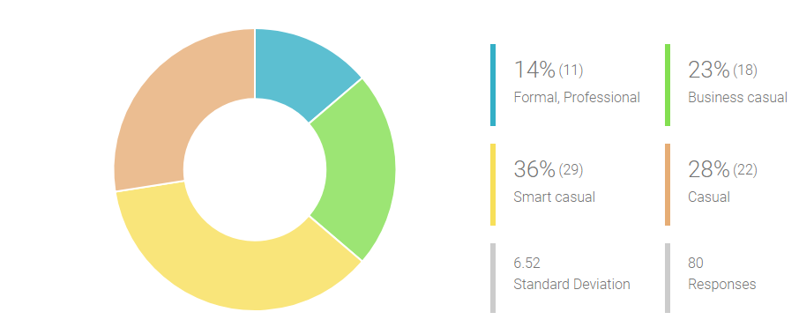

Figure 4.1. Answers from the survey about a dress code at work

Source: developed by the author from the conducted survey

Next important thing was to understand what respondent’s habits of shopping workwear are, which are the places where they shop, is it more online or offline. Based on this information it is also easy to understand what the trends are as basically all shopping malls in Latvia offer the same brands. From answers its visible that shopping malls are the most popular shopping place, following online stores and outlets in other cities. The most variety of places where to shop the workwear has age group 30 to 34 as 39% from responses for this age group go to shopping malls, 28% also use online stores and 16% go to outlets in other countries, this is also the biggest age group use custom made option and local Latvian design shops. Next group with a variety of place for shopping workwear are age group 25 to 29, mostly prefer shopping malls, and online shops but less than age group 30 to 34, only 20%; this age group also likes local Latvian design shops and outlets in other countries at the same level – 14%. Third biggest age group of 35 to 39 prefer shopping malls and outlets at the same level and online shops much less. Custom made workwear has tried age groups from 30 to 49 (see figure 4.2.).

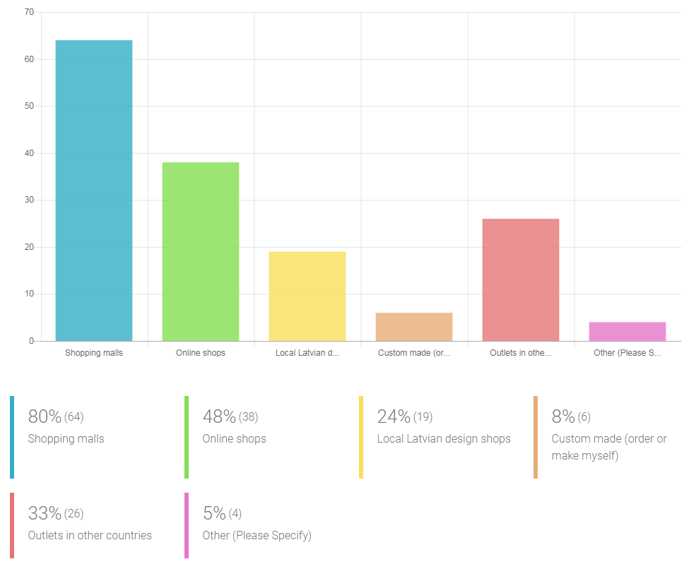

Figure 4.2. Answers from the survey about places for shopping workwear

Source: developed by the author from the conducted survey

Moreover, if analyzed from gross monthly salary level, then shopping malls are the most popular choice for all salary levels, online store usage is more popular amongst respondents earning a gross monthly salary from 1500 to 2500 euros and from 4001 and above. Outlets in other countries have the popularity amongst respondents earning 1500 to 2000 euros and above 3001 euros as gross monthly salary. The custom made option has more chosen respondents with a salary level of 1500 to 2000 euros.

Next survey question relates to an opinion if there is enough choice for workwear in shops in Latvia and respondents chose using Liker scale if they agree or disagree with this statement. Strongly disagree was valued at zero and strongly agree as five. Weighted average outcome is three, which means that respondents more agree that there is a lot of choice in Latvia shops to choose from. 56 respondents from 80 answered as more agree than disagree (see fig.4.3.).

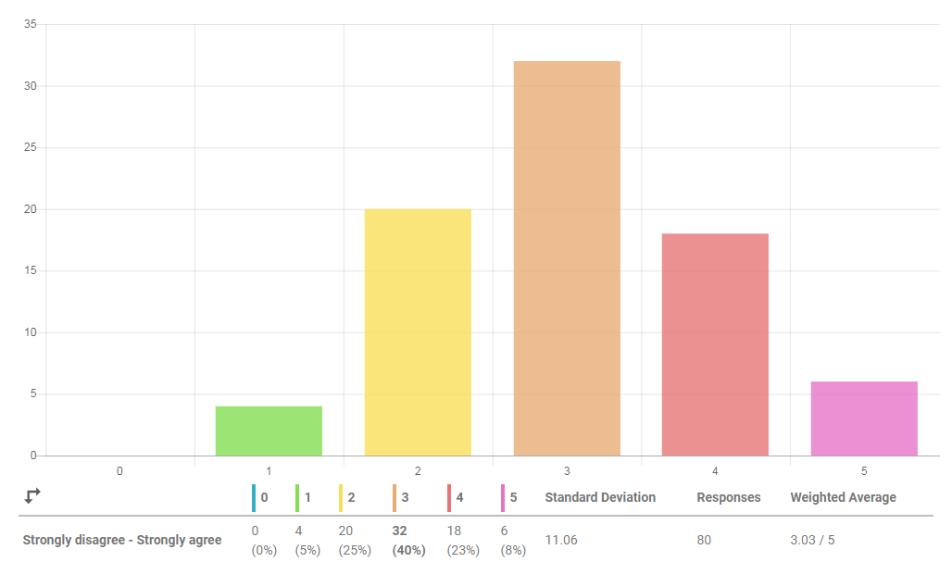

Figure 4.3. Answers from the survey about a choice of workwear in Latvia

Source: developed by the author from the conducted survey

To get information on what is important for the customer when choosing clothes for work, respondents were asked to rank five factors based on their importance when choosing clothes for work. First raked is most important and fifth is least important. From the analysis it is visible that quality of fabrics is most important factor thus keeping in mind that most of the respondents’ shop in shopping malls which are full of fast fashion brands, this feature should be kept in mind for company’s marketing campaigns. Price is following the quality as a second important factor, a third is the uniqueness of the product, so it differs from mass production. This is a common trend from women which could be fulfilled by custom made clothes. Fashion trends and brand name are ranked as two least important. If we look at brand ranked at last one, this is a common trend in whole customer thinking, as several market types of research done in Europe and United State retail markets, shows that brand names are not the most important for customers anymore. If analyzed by age groups, then quality and price are valued as very important for age groups from 20 to 34 and brand name and fashion trends have very similar importance. Age groups above 35 have different views of this and after quality value as important uniqueness and brand name (see fig.4.4.).

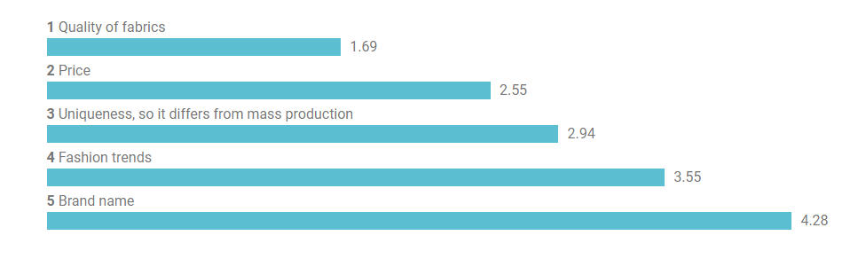

Figure 4.4. Answers from the survey about most important factors for choosing workwear

Source: developed by the author from the conducted survey

As next question, respondents valued if they buy more clothes to be able to change or less but the higher quality which last longer, but also the price is higher. 65% of all respondents better choose higher quality which is a good feature for a custom-made clothing company, as the quality of products is higher. If we look from salary levels on this question, then a visible trend is that respondents earning more than 2501 euros mainly choose higher quality but less, and other groups earning less than 2501 euros choice is around 65% and 35% more agreeing on buying higher quality but less. Only age group who want to buy more is age 20 to 24, all other groups mostly choose the second option (see fig.4.5.).

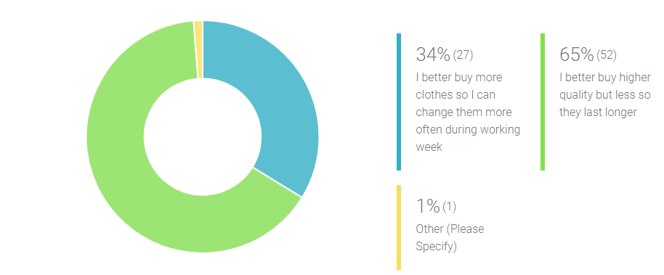

Figure 4.5. Answers from the survey are the quantity of clothes more important than quality

Source: developed by the author from the conducted survey

Further on respondents should value the importance of fabrics from which the clothing is made. This question is aligned with importance factor ranking and basically shows the same result, thus here additionally emphasis is on the importance level. With zero is valued not an important quality of fabrics and with five valued that fabrics of workwear are extremely important (see fig.4.6.).

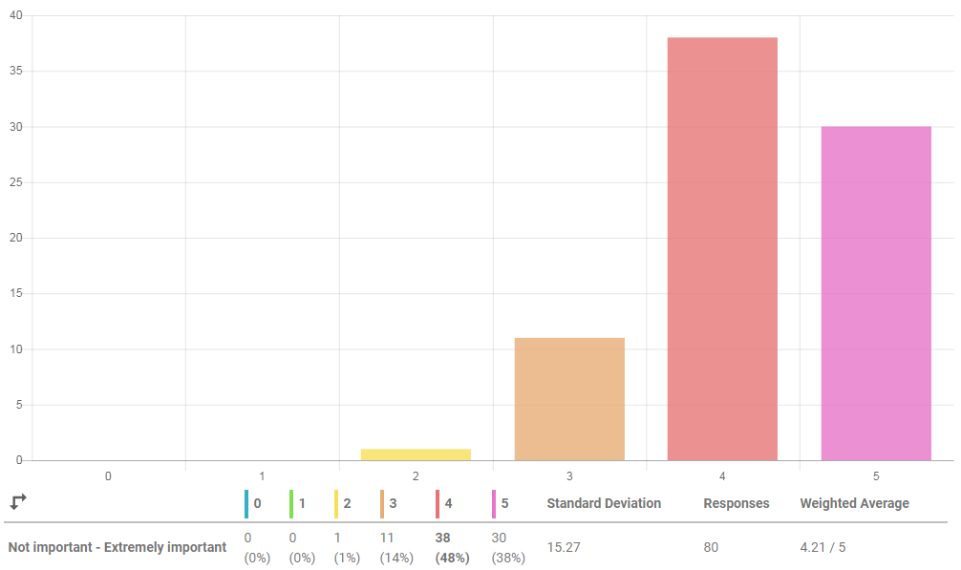

Figure 4.6. Answers from the survey are the quality of fabrics important

Source: developed by the author from the conducted survey

Custom made clothing usually is time-consuming and trust and good relationships are crucial for choosing the producer. The factors of choosing custom made clothing should be analyzed to understand what respondents value using this service and what could be possible constraints for the company to address them. There are four factors: choice of designs, choice of fabrics, time from order to delivery, the process of taking measures and fitting. Ranking is done valuing with 1 the most important and with 4 least important. All four factors ranked between 2.15 to 2.88 which mean they are very close, and results differ for respondents. For the age group 20 to 34 most important is the choice of designs thus age group 35 to 39 value more choice of fabrics and equally choice of designs and time when the product can be ready. For the age group 20 to 24 all factors have very close results. For the age group 45 to 49 time is most important, leaving the process of taking measurement and choice of fabrics as second important and designs the least important (see fig.4.7.).

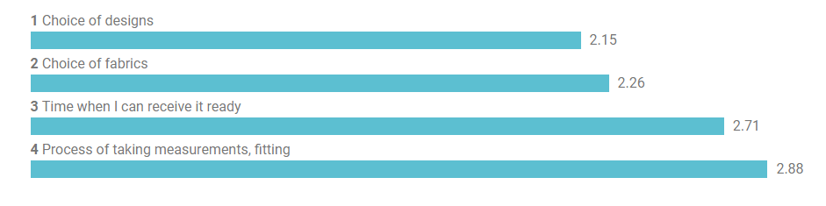 Figure 4.7. Answers from survey to rank the factors important for choosing custom made workwear

Source: developed by the author from the conducted survey

Market research conducted for Europe retail market shows that time to receive the products usually is a most critical factor. For purpose of this study, the question in the survey included valuing possible time respondent can wait if order custom made clothing. Results show that only a few are able to wait few days, the main part of respondents are able to wait one or two working weeks and for 36% it is not even critical (see fig.4.8.).

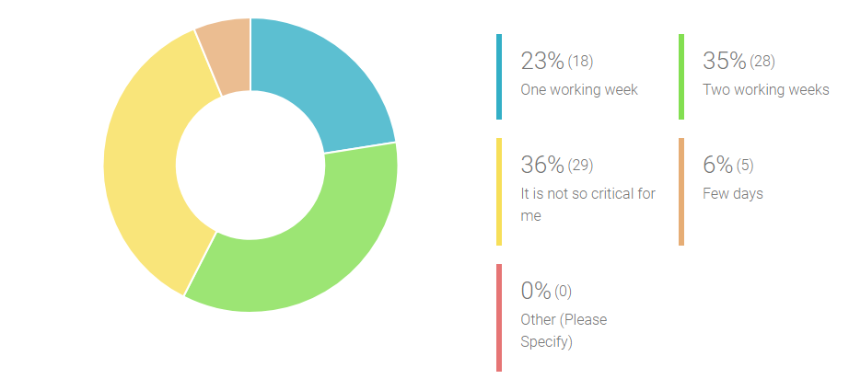

Figure 4.8. Answers from the survey about waiting time of custom-made clothes

Source: developed by the author from the conducted survey

Further, on for purpose of this study, respondents were asked to identify the best option for buying custom made clothing, results are important for the company to make a decision whether to choose a pureplay online model or online and offline sales channels. If analyzed from an age group perspective, then all age groups except age group from 30 to 34, with more than 70% choose showroom option, for age group, 30 to 34 showroom option chose only 57% and remaining 35% chose both. 91% of respondents in the age group 35 to 39 also choose showroom option (see fig.4.9.).

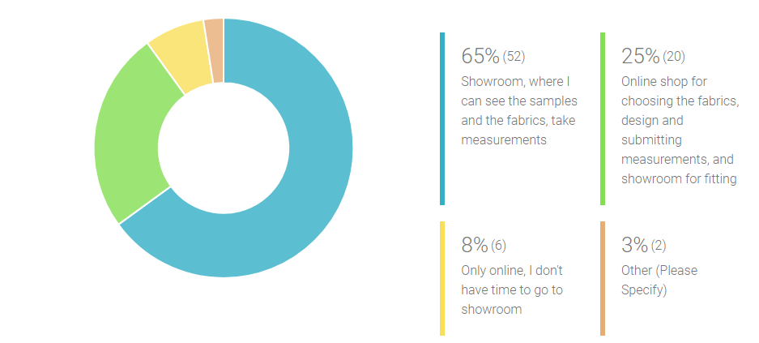

Figure 4.9. Answers from the survey about options to buy custom made clothes

Source: developed by the author from the conducted survey

For purpose of this study, also question of the composition of the product was included in the survey, which gave results about the best type of set desired by respondents. From results can be concluded that three-piece sets are more popular than two-piece set. Age group from 20 to 24 prefer a three-piece set of jacket, skirt, and trousers more than other options. Age group from 30 to 34 prefer most three- piece set of jacket, skirt, and dress, but all other age groups prefer three-piece set of jacket, trousers and dress. Two-piece sets are mostly valued by the age group of 25 to 29 (see fig.4.10.).

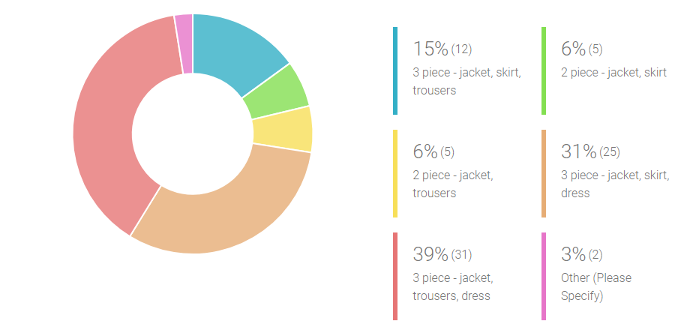

Figure 4.10. Answers from the survey about the best composition of business suit for women

Source: developed by the author from the conducted survey

To get information from respondents about their willingness to buy custom made clothes for work, intention-to-buy type of questions was included in the survey. The first one about the fact if respondents are willing to buy the custom-made clothing showed favorably results as 41% from respondents stated that they would buy custom made clothes for work and 13% definitely buy. This was scaled from zero to five where zero meaning was definitely not buying and five was definitely bought. Analyzing from salary level perspective, there are no visible trends that respondents with lower salary are more likely not willing to buy custom made clothing, there is the same trend for all salary level groups, respondents are more likely to buy custom made clothes for work. The same tendency is visible if analyzed from the age group perspective (see fig.4.11.).

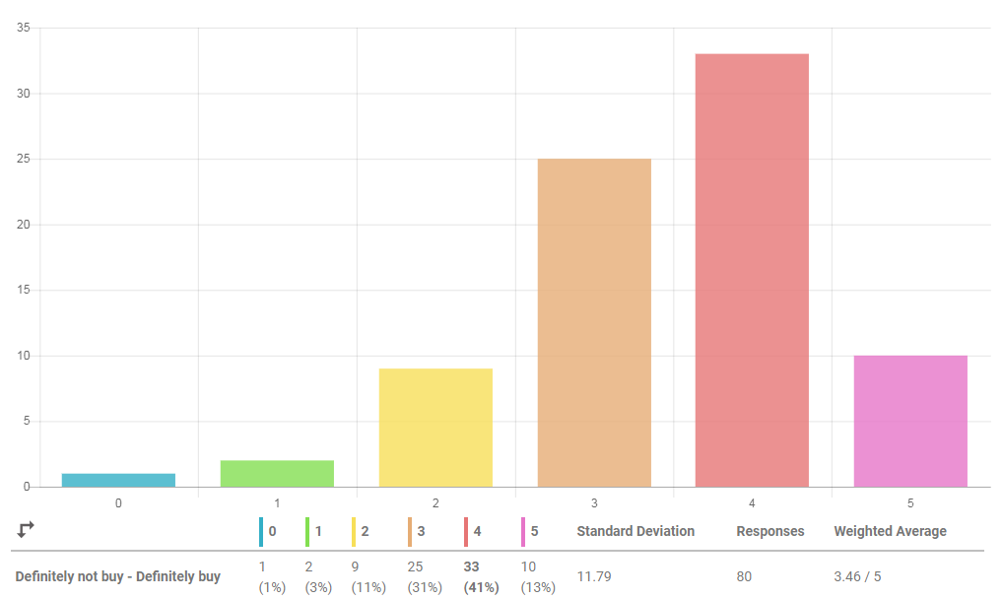

Figure 4.11. Answers from the survey about the intention to buy custom made clothes for work

Source: developed by the author from the conducted survey

Following intention-to-buy question for purpose of this study was intention-to-buy custom made business suit for 450 euros. This is the price company has calculated as the price for the product and based on what all financial information for purpose of this study has been made and will be looked in details in next chapter. The analyze of answers from respondents shows that 33% of respondents are ready to buy this product for the defined price, 13% more likely buy and only 5% definitely buy, this leads to weighted average 2.4 which from zero to five scale is little less than half. However, with efficient marketing and influencers on social media, this could be changed. A deeper analysis of respondent types should be looked at. Analysis by salary level shows that respondents with gross monthly salary level from 1500 to 2000 euros 52% most likely not buy for this price and 48% more likely buy. Respondents with salary level from 2001 to 3000 euros more likely buy custom made business suit for this price. Group earning from 3001 to 4000 euros most likely not buy for this price and respondents with a salary above 4001 euros split into two equal parts for intention to buy for this price (see fig. 4.12.).

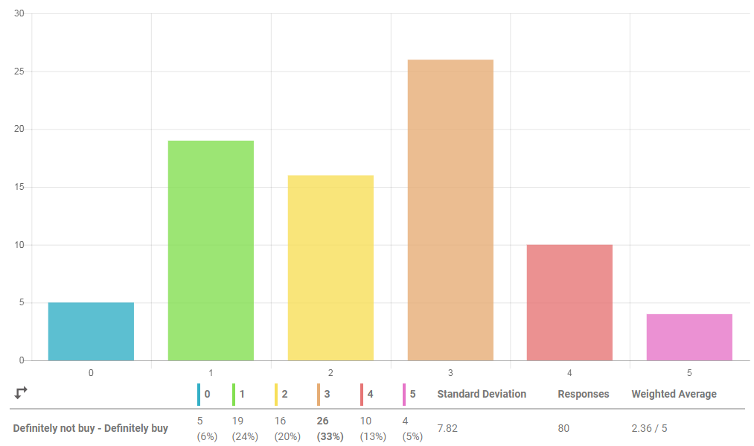

Figure 4.12. Answers from the survey about the intention to buy custom-made suit for 450 euros

Source: developed by the author from the conducted survey

At the final stage of survey respondents were able to express an opinion on the open-ended question about the experience of custom-made clothing, what are the feedback of choosing this option. Firstly, usually, respondents have chosen custom-made clothing for festive events and not for workwear. Most of the experience if any is bad, there is stated that expectations usually are higher than the performance of producer. As positive is named option for good quality fabrics and colors that suit the best. As negative is timing, and attitude of tailor if some changes for the garment is necessary. The major part of respondents has never tried to order custom made clothing and likes to try clothes on spot not waiting for the result.

# Analysis and conclusion

## Hypothesis testing

For purpose of this study, the author defined two hypotheses:

* H0: the introduction of a new clothing line for women in Latvia, will not generate a profit in the first two years
* Ha: the introduction of a new clothing line for women in Latvia will generate a profit in the first two years.

In order to test the hypothesis, the author has used primary data outlined in Chapter 4 and secondary data outlined in Chapter 3 and Chapter 5. Chapter 4 primary data used for forecasting demand for investment company and information gathered in Chapter 3 and Chapter 5 used for retail industry analysis for proper financial forecast projection for the investment company.

Based on this primary data the author has created a financial forecast for the retail company for the first three years.

### Financial forecast for three years

Financial forecast made up to three years with three different scenarios. Calculated product production price is 303.90 euros, which includes three-piece business suit with jacket, trousers, and skirt fabric, lining and production cost for the full set. Fabric, which is wool, wool-and-silk mix, wool-and-cashmere mix and all three mix, lining, is silk and or viscose. Price calculations are based on actual fabric cost and quantity, and production cost is based on sewing company price list. Selling price is calculated based on benchmark taken from local retail industry companies and is 47%, totaling 450 euros. The business suit can be purchased as a set and not separate.

Company’s product for Latvia market will be unique as an offer for business suits for women is very weak. For market share calculation taken local retail- clothing companies which in the Latvian market do not play a role as competitors for the company but has started a business from scratch a few years ago and have faced success. Fashion brand CooCulte, which belongs to company Lingerie Baltic Ltd., operates since 2004 and right now has shops in 7 countries. It offers dresses, skirts, jackets, and leggings in its own design and is very famous in Latvia. Turnover for 2016 was 436 thousand euros and its 164% growth compared with 2015. Gross margin 46%, Net profit margin 7%. They just a few months ago opened an online shop. More famous for women above age 25 is Amoralle brand, which belongs to Glamoralle Ltd., and operates since 2008. They started as an international online shop and right now has a showroom in main street of Riga center. Amoralle label has gained international recognition. Its legwear, lingerie and nightwear store offering high quality, royal luxury, and refined details. Turnover for 2016 was 1 260 thousand euros which is 41% growth compared with the previous year. Gross margin was 42%, which doubled if compared with 2015 and net profit margin was 11%, also doubled from 2015. The third notable brand is ZIB*, which is ZIB* Tekstils Ltd. and operates since 2012. It offers comfortable and original jersey clothing as well as bright accessories. All ZIB* prints are based on designer drawings and paintings; therefore, each item is unique and different by its color tone or paint drops on the fabric. Turnover in 2016 was 276 thousand euros and is 71% growth if compared with 2015. Gross margin was 29% and has a slight increase by 6% compared with 2015. Net profit margin in 2016 was 15% and its significant growth from 1% for 2015.

These companies operate in the retail clothing industry in specialized stores market which turnover in 2016 was 336 304 thousand euros, market turnover increased by 5% in 2016 if compared with 2015. Market share for CooCulte is around 0.13%, for Amoralle 0.37% and for ZIB* 0.08%. Considering that company will offer high-quality suits for women, then as a target for market size in 3 years period since starting is 0.37% market size as a benchmark from Amoralle brand. If we look at the retail sale of clothing in specialized stores market growth trends, that based on latest projections according to CSB is 4% yearly, then based on calculations target market share for the company in 5 year period is 0.37% or 1 457 thousand euros (Central Statistical Bureau, 2018).

The company has a share capital of 1 euro, which is allowed if a number of employees are not exceeding 5 persons. Bootstrap financing is used, owner investment of 20 thousand euros as a long-term loan without interest payment in a 5-year period.

Three scenarios are made and assumptions for realistic made to reach sales units 205 in the first year, 315 in the second year and 635 in the third year, production cost 303.90 euros selling price 450 euros.

The financial plan made based on real prices and assumptions. For all three scenarios, administrative costs remain the same. There is only one employee working for all three years, first-year monthly gross salary is 550 euros, totaling in the income statement for 682 euros monthly, and from a second year there is gross salary increase to 750 euros, totaling in income statement 931 euros monthly. On the third-year gross salary is 2500 euros monthly, totaling in income statement 3102 euros monthly. Showroom place rent and utility expenses monthly assumed 270 euros, not changing for three years. Additionally, to administrative costs planned outsourced accounting costs 70 euros monthly, a constant cost for all years. Bank fees and web hosting monthly planned constant cost of 1.2 euros and 50 euros respectively. Google AdWords cost the first year 50 euros monthly and starting from the second year 70 euros monthly. Marketing costs planned in the first year only partly for five months from August to December in women magazine Santa which has the largest edition in Latvia 45 thousand readers monthly. Monthly it is 450 euros, starting from second-year magazine ad planned to be 10 months skipping two summer vacation months June and July. For the first year there is planned one-off costs such as webpage design which includes also online shop design. The assumption is made that it will cost 6 thousand euros as it will be custom made. Around 1 thousand euros planned for place maintenance and improvement, so it fits for the showroom. There is planned set up costs around 600 euros for registration of the company, cash machine purchase, packaging purchase and office expenses.

Optimistic scenario made based on assumption that sales increase +15% from a realistic scenario and selling price is higher, and it is 500 euros. Pessimistic scenario is made based on assumption that sales decreased -15% from realistic scenario and production cost and selling price stays the same. In addition, production units adjusted for each scenario so there is no slow inventory. For financial analysis comparison information from Aswath Damodaran online website taken information for apparel industry averages in Europe (Damodaran, 2018). All three scenario financial statements including Income Statement, Balance Statement, ratio analysis, and Cash flow included in Appendix 3. In addition, industry averages included after financial data in Appendix 3.

Break-even point calculated and its 159 units (see fig.5.1). Based on sales assumptions made for all three scenarios, break-even point will be reached for realistic scenario and optimistic one in the first year and pessimistic scenario in second year.



Figure 5.1. Break-even point for the company

Source: developed by the author based on calculations

Further, please see main data from financial analysis. Industry averages compared where it was available. Turnover growth planned in all three scenarios, in pessimistic it is slower. To reach market share 0.37% in 5 years realistic scenario should be exceeded 4 times for the next 2 years after 3rd year to reach the target. That could be done investing heavy in marketing (see fig.5.2.).



Figure 5.2. The turnover projection for the first three years for three scenarios in euros

Source: developed by the author based on calculations

Units sold differ only by 15%, thus selling price increase in optimistic scenario gives higher turnover if compared. Price change from 450 euros to 500 euros should be considered carefully to not afraid customers. To reach a market share in 5 years, possibly could think about special business suit line which could be more expensive (see fig.5.3.).



Figure 5.3. Units sold projection for the first three years for three scenarios

Source: developed by the author based on calculations

Gross margin does not differ a lot for all 3 scenarios, as for realistic one sales plan made based on assumptions in first year, for other scenarios produced amount kept at a very low level to reduce inventory, thus this could be risky, if demand is in market but the company has situation nothing to sold or long production time. The industry average is 62% which is half more thus this could be explained with lower production costs as companies included in the calculation for apparel industry averages are big retailing groups. Benchmark used for market share to reach is 47% and closest is an optimistic scenario in the third year, thus more production should decrease the cost for next years. The optimistic scenario has a huge impact due to higher sales price (see fig.5.4.).



Figure 5.4. Gross margin (%) and Net Income in euros for the first three years for three scenarios

Source: developed by the author based on calculations

Net profit is positive for realistic and optimistic scenarios in all three projected years, for the pessimistic scenario it is negative only in the first year and this is due to higher costs in the first year and lower sales amounts planned. However, the realistic scenario gives profit in first year 2 thousand euros and the second year 16 thousand euros which accumulated for the first two years gives a profit of 18 thousand euros. The optimistic scenario gives higher profit mainly due to the higher product price and increased sales amounts. For the first two years, optimistic scenario profit is 58 thousand euros thus pessimistic scenario will give only 10 thousand euros profit.

The average return on invested 20 thousand euros based on the realistic scenario for the first year is not so good, thus positive, for second and third year it is decent. Thus, here should be considered that no interest payment is paid during the first three years based on financial projections. The pessimistic scenario gives a negative average return on investment in the first year due to high one-off costs of webpage development and premises design costs. The optimistic scenario gives the most favorable returns in all three years (see fig.5.5.).



Figure 5.5. The average return on Investment (%) for the first three years for three scenarios

Source: developed by the author based on calculations

The net profit margin for the industry is 8% which is around the same for realistic and pessimistic scenarios in the second and third year. It is a little bit higher than industry, which could be explained with lower fixed costs than the industry as gross margin is higher in the industry as visible previously. Comparison of profit margin for all scenarios done (see fig. 5.6.).



Figure 5.6. Net profit margin (%) for the first three years for three scenarios

Source: developed by the author based on calculations

A similar trend with industry averages and three scenarios visible when analyzed EBITDA margin which stands for earnings before interest, tax payment, and depreciation and amortization costs. For industry it is 10% higher than profit margin, for all scenarios, there is slight increase only which could be explained with no interest payments and no fixed assets and intangible assets. EBITDA margin for all three scenarios and industry average compared (see fig. 5.7.).



Figure 5.7. EBITDA margin (%) for the first three years for three scenarios

Source: developed by the author based on calculations

### Retail industry analysis according to the Five Forces model

Retail industry has been analyzed constantly globally and country wise. One of the important research sources MarketLine analyzed the apparel retail industry in Europe (MarketLine, 2018).

Latvia is part of Europe and market participant since joined European Union on 2004. Latvia is importing apparel more than exporting based on statistics and retail chains visible in main shopping malls and streets. This is the reason why its eligible to look at the retail industry in Europe to understand common trends. Based on market research described in the previous chapter lot of purchases for clothes are done in online shops and outlet stores in other countries. These mainly are European countries.

European apparel retail industry in 2017 reached value of 356.1 billion euros Its 3.1% growth compared with 2016, the largest segment is womenswear 57.1%. Research projects growth until 2022 for 17.8%. Germany is the biggest player in the industry taking 16.8% of total value, Italy follows closely with 13.7% and the United Kingdom with 13.0%. There is moderate growth in the industry with project growth in future years (MarketLine, 2018).

The same research also states possible projections for future years.

There is visible growing popularity of shopping online which has an impact on apparel retail industry, this sector in Europe grew by 12% in 2017 and projection shows that it will increase by 62% until 2022. Only online shops in 2017 have taken 7.5% from total apparel retail industry value, 62% of specialty stores, 10% of department stores, 6% are hypermarkets, supermarkets, and 14.5% are other distributors. Still, there is strong performance of specialty retailers thus selling in both channels (online and offline) is beneficiary for them. (MarketLine, 2018, p. 7)

Fast fashion is the most profitable sector in the industry, such online retailers as ASOS and Boohoo have experienced strong growth. Fast fashion term is clothes that are inspired by recent fashion trends seen in social media and on celebrities, sold for affordable prices. “Europe apparel retail industry main players are H&M and Inditex which operates thousands of stores and create a formidable hurdle for rivals and new entrants to overcome and make industry highly competitive” (MarketLine, 2018, p. 8). There is a number of retailers who closed the shops in the UK, however, Italy is known for luxury designer brands and targets only small demographic.

Based on research five forces analysis is done taking retailers as players, key buyers are taken as individual consumers and clothing manufacturers and wholesalers as key suppliers. “The presence of strong incumbents and relative lack of diversification in this industry increases the competition between players. Moderate growth in Europe alleviates the degree of rivalry between players and reduces the likelihood of a zero-sum game” (MarketLine, 2018, p. 14).

Research shows that forces driving competition in the apparel industry in Europe in 2017 are valued as follows:

* Buyer power assessed as moderate
* Supplier power assessed as moderate
* New entrants assessed as strong
* The threat of substitutes assessed as weak
* The degree of rivalry assessed as moderate (MarketLine, 2018).

According to research strongest drivers for buyer power are low-cost switching and buyer independence. Also, the tendency to switch and undifferenced product.

There is plenty of choice for buyers and they are easily swaying from company to company. Apparel is very important for consumers and retailers must keep in mind that trends come from most forms of media for which they need to remain aware. This is the industry where happens unpredictable and rapid changes in fashion, and players need to offer buyers what they demand. This driver increases buyer power. Brand consciousness is substantial, but brand loyalty is low. The price sensitivity varies regionally. However, retailers can differentiate themselves through styles they offer and price range, meaning the buyer power is weakened. Price can also be factor as low price is offered only in fast fashion stores. Majority of customers lack financial muscle and backward integration is not a possibility. (MarketLine, 2018, pp. 15-16)

Main drivers of supplier power are the importance of quality/cost and no substitute inputs. Supplier power in industry decreased through manufacturers in low-wage regions such as Asia-Pacific. Despite this Corporate Social Responsibility is becoming important for the industry. This comes along with transparency of full supply chain and governance practices that are employed in facilities. More ethical way of performance is required not only from non-governmental organizations but also from consumers. Suppliers which are successful in this field are in high demand. Retailers switching costs are nor very high, thus there is a risk that new supplier will not be able to manage the rapid change in fashion or supplier has a longer supply chain. Supplier power is decreased because of the lack of diversity. Another future driver of supplier power is the difficulty of automating processes, as making garments is labor intensive work. If Asia-Pacific region in future will increase minimum wages that will be a problem for fast fashion companies. Automation of production will be advantageous for companies which will be ready for this (MarketLine, 2018).

New entrants are not having a high cost for entering and capital requirements are low. However, H&M and C&A account for a large share of industry revenues. There is tightening competition for low price retailers. There is a tendency to overproduce brand production or repeat last years collections to keep stores full. Retailers should look at how to keep cost low to offer desired prices. There are local governmental regulations in some countries for imports and exports which could also impact lowering prices if necessary, to compete in the market with low-cost country products. New entrant power is increasing the low cost of switching for buyers and weak differentiation between products (MarketLine, 2018).

The threat of substitutes drivers are alternatives to retail as there are no substitutes for apparel as such. Research describes the threat of substitutes.

Factors influencing the threat of substitutes is a cheap alternative and low-cost switching. The option is to buy directly from the manufacturer and growth of online shops facilitates this. Multi-channel approach in the apparel industry will be wide-spread. Amazon fashion online store is a threat for pureplay online shops. Custom-made clothing is also niche alternatives to the retail ready - made clothing. (MarketLine, 2018, p. 21)

Afterwards, research describes main influencers for the degree of rivalry.

Drivers of degree of rivalry in the retail industry are low-cost switching, undifferentiated product, the similarity of players and lack of diversity. In the industry there is a place for a large number of small players who have the opportunity to capitalize on changing consumer shopping habits. Big data have helped such companies as ASOS and Zolando to understand the needs of consumer and influence next purchase. Retailers must establish proper social media presence for communication with customers. Enhancing in-store experience is very important to get a competitive edge over rivals. Product innovation is constant in the industry and more new categories along the lifestyle brands and new collections like plus size, tall, petite and others are created. (MarketLine, 2018, pp. 22-23)

Online retail is rapidly taking over the industry and as described earlier, pureplay online stores are having 7.5% from total retail revenues, thus more than half of retailers have multiple channels which is online and offline. There is analysis made for online retail in Europe in 2017 which is used for retail industry analysis also for Latvia as part of this market. The Five force model analysis is done for online retail and afterward compared with retail industry analysis to see specific differences between previously analyzed retail sector.

MarketLine (2018) research for online retail in Europe shows that in 2017 sector growth was 12.3% reaching 197.9 billion euros and is projected to grow in five years 10.3%. In 2017 the biggest segment in online retail was electrical and electronics retail with 28.1% of total share of revenues, following 25.9% apparel retail and 16.9% food and grocery retail (Marketline, 2018).

“Five forces analysis done taken online retailer as players, key buyers as end consumers, information and communication technology systems, suppliers of third-party logistics services, and packaging material suppliers as key suppliers” (Marketline, 2018, p. 14). Forces driving competition in the online retail sector in Europe valued as:

* Buyer power assessed as moderate
* Supplier power assessed as moderate
* New entrants assessed as strong
* The threat of substitutes assessed as moderate
* The degree of rivalry assessed as strong.

Buyers are small in size and with little financial muscle. Drivers for buyer power are low-cost switching, tendency to switch, price sensitivity and product dispensability. Buyer power increases with technologies as it is possible to compare and find the cheapest price in a short time. Customer loyalty to well-known and trusted retailers tend to increase due to security concerns online purchases have. Expansion of e-commerce also drives backward integration of consumers as its possible to sell online in eBay and Aliexpress. This increases buyer power (Marketline, 2018).

Supplier power drivers are differentiated input and supplier size. Logistic services, packaging, and most importantly information and communication technology system developers have power in their hands. Suppliers of differentiated products and brands enjoy more power than suppliers offering commodities if they supply to more than one retailer the power increases. Supplier power is diluted as there are low of many small producers who can sell directly to the consumer using eBay. Logistic companies enjoy strong power as in online retail speed and quality of delivery is very important. Delivery is usually third-party service for the retailer. The packaging of goods takes a lot of overhead costs to retailers (Marketline, 2018).

The main description in research for new entrants and main constraints retailers have described further.

New entrants influencing factors are low-cost switching, market growth, suppliers and distribution accessible. New entrants can be new companies or already existing ones expanding the sales channels. Low entering costs and low capital investments increase new entrant power. Online retailers have the option to sell internationally, there is no need of a physical presence in another country to be able to get sales from there. However, tax duties, exchange rates and delivery times should be considered. Expansion of online retail has led to increased investment in research and development for online retailers to develop mobile apps with artificial intelligence and improve the consumer experience and retailers reach. This factor hinders small online retailers’ expansion. Information and communication technologies and logistics are key for further expansion of industry and also new entrants. Trade regulations could impact new entrants as there are data regulations in place in Europe which forbids the transfer of consumer data outside European Union countries unless this country offers proper data protection. (Marketline, 2018, pp. 19-20)

The threat of substitutes is only applicable to pureplay online retailers because retailers that have multi-channel sales including online do not face this threat. Factors of a consumer choosing other options not online are delivery time, security of online transactions (Marketline, 2018).

The same research describes the main outputs for last but not least driver of competition in the industry.

Drivers to the degree of rivalry are easy to expand, low-cost switching, low fixed costs, number of players. Large retailers in this sector benefit from large sales volumes, economies of scale and are able to reduce prices against what is hard to compete for smaller retailers. Large retailers can offer free delivery and returns, which cannot be an option for smaller ones. On the other hand, the fact that competition goes abroad country borders adds intense to rivalry conditions. However, customs policy and exchange rates for some domestic retailers can be a protection shield from international online retailers. Competition tightens as in this sector are retailers doing multi-channel sales not only relaying to pureplay online. Undifferentiation of products tightens price competition as there are the same brands offered in many online stores. Storage costs are high and the operation cycle is very short for the online retail industry. Investments in systems that manage these processes are high and available to large companies mainly which improve their market shares. (Marketline, 2018, pp. 22-23)

If compare apparel retail and online retail industry in Europe considering that the highest the number from 0 to 5 the more significant impact on industry factor has, main force driving competition in online retail and apparel retail is new entrants (see fig.5.8.). For online retail industry degree of the rivalry has a huge impact on competition as its low cost and low capital investment needed for establishing an online store. Supplier power and buyer power have a similar impact to competition thus for online retail also substitutes gives impact as pureplay online stores can be substituted with offline sales channels.

Figure 5.8. The Five Force analysis for the Online retail and Apparel retail industry in Europe

Source: Developed by the author based on MarketLine research (2018)

### PESTEL analysis for retail industry

The author looks at political, economic, social, technological, environmental and legal factors (PESTEL) that have an impact on the retail industry in Latvia.

Political factors to consider are government policy, political stability, taxes, industry regulations, global trade agreements and or restrictions.

Government policy is positive for new start-up companies as Saeima has adopted Law on Aid for Start-up Companies in 2017 to promote the formation of start-ups. Law provides favorable tax regime if the company meets such criteria – the company is less than five years old, earning below two hundred thousand euros revenues in first two years, earning less than five million euros during first five years, not paid out dividends and securing tax debt for the company (Ministry of Economics, 2017).

The government in recent years has made improvements in differentiation of business forms which improved new company foundation. Based on information available in Register of Enterprises, there are 203 thousand enterprises registered and 58% from them is limited liability companies (LLC) with share capital from 2800 euros, 15% small capital limited liability companies with share capital from one euro to 2799, 10% from all enterprises is farm undertakings, 6% individual undertakings and other different forms of business. Significant growth of a number of registered small capital LLC started in 2010 and shows a growing trend each year. A number of registered standard LLC decrease from 2011 (The Register of Enterprises, 2018).

Importance on the industry is high, as there is simple access to start a business which impacts rivalry in industry.

Government policy improves data protection. Latvia is a member of Schengen Information System which is maintained by European Commission and members are 31 countries. Its purpose is national security, border control, and law enforcement. Since May 2018 Latvia also falls under the governance of the General Data Protection Regulation (GDPR) introduced in the European Union. From this will especially benefit small and medium-size enterprises as it offers cost-effective cross-border access to new markets to businesses, as before there was a need to adapt to each different national data protection law. GDPR relates to all companies processing personal data in European Union (Data State Inspectorate, 2017). Importance in the industry is high as firstly there are rules that each company should comply with that could take additional investment on data processing and storage, and as the benefit is one rule to comply with for all European Union where retail industry is growing.

Government policy supports the development of infrastructure a transport and logistics industry are one of the most important ones due to favorable geographic location. According to The World Bank Logistics Performance Index from 160 countries, Latvia takes 70th place in 2018 (The World Bank, 2018). Latvia has favorable location between the European Union and largest markets to the East, it has an external border with Russia and Belarus, the Schengen membership and well-developed internal infrastructure gives a positive impact on transportation and logistics. The government also made a decision to involve in Rail Baltic project, improved Via Baltica transport corridor connecting with Scandinavia, Russia, and Eastern Europe. For the retail industry, this is positive impact and importance is high, as basically all apparel for retail are imported.

Custom policy for imported goods falls under Regulation European Union Customs Code, there are only a few documents to submit, there is free circulation of goods and the same duty applicable to all member states according to Common Custom Tariffs (European Commission, 2013). Importance for the retail industry is high as there is the easy import of goods into Latvia market which increases rivalry.

Tax policy is an important political factor. The main taxes are social insurance contribution (24.09% for employer 11% for employee), personal income (20%, 23% and 31.4%) and value added tax (21%). Minimum wage in 2018 is 430 euros, it has increased by 110 euros since 2014 and 13% if compared with 2017. Corporate income tax should be paid only when dividends are paid. If a company invest money in development, then no tax should be paid. This is new regulation started only in 2018.

Economic factors impact how each company does business and how profitable market players could be. Here important is to look at the economic growth rate, interest rates, exchange rates, inflation, and disposable income consumer has for spending.

The economic forecast for Latvia is projected to moderate to under 3.5% by 2020 according to the Organization of Economic Cooperation and Development (OECD) which member state is Latvia. Private consumption is supported by strong earnings increase and strong labor market which is tightening. Investments were down but right now due to European Union structural funds has rebounded in 2017 and 2018. Capital growth is projected in a two-year period. Export will grow slow along with world trade. Based on projections net exports remain negative in a two-year period (OECD, 2018).

European Commission Autumn Forecast for Latvia states the same projections and emphasis consumer optimism which will drive private consumption growth. Construction increase will continue in coming years, supporting labor and income growth for individuals, lowering unemployment rates. Based on this forecast inflation in 2018 will be 2.7%, 2019 and 2020 2.7% and 2.4% respectively (European Commission, 2018).

Disposable income growth has shown a growing trend for several years already. Central Statistical Bureau (CSB) conducted a survey to gather data for household disposable income and results showed a 4.9% increase in 2016 if compared with the previous year (see fig.5.9). Structure of disposable income mainly consists of income from labor 71.2%, social transfers 24.7% and 3% income from self-employment and 1.1% other income. The structure basically is the same in all years.

Figure 5.9. Monthly household disposable income in euro in Latvia from 2006-2016

Source: developed by the author based on CSB (2018)

Disposable income growth has a positive impact on the retail industry as there is more money to spend for consumers. Together with income growth changes also consumer preferences where to spend money. The author analyzed the structure of household consumption expenditure structure and there are no significant changes during the 10-year period from 2006 to 2016 (see fig.5.10). Spending on clothing and footwear in recent years increase slightly but not significantly.

Figure 5.10. Household consumption expenditure structure (%) from 2006-2016

Source: developed by the author based on CSB (2018)

Another economic reason for increased income could be increase in savings which could impact the retail sector as there is an increase in disposable income which household decide to keep as saving and not spend in the market. In 2016 household savings increased by 1 billion euro or 8.9% if compared with 2015, it is mainly deposits held in Latvian commercial banks and funds invested in 2nd and 3rd pillars of pension scheme totaled slightly below ten billion euros. Composition in 2016 is the following: 61% deposits, 29% is 3rd pillar pensions, 6% are financial instruments and 4% is 2nd pillar pensions. Financial and Capital Market Commission states that the same trend continues also in the year 2017 reaching 10.4 billion euros household saving (Financial and Capital Market Commission, 2018).

Average monthly salary changes also have an impact on the retail industry, this comes along with household disposable income, of course, thus for targeting specific market niche in the retail industry, salary level is a very important indicator. The author made an average gross monthly salary trend for the public and private sector to see the increase (see fig. 5.11.).

Figure 5.11. Average gross monthly salary by kind of activity from 2007-2017 in euros

Source: developed by the author based on CSB (2018)

Average gross monthly salary is growing in both the public and private sectors from 2010. The public sector has higher average gross monthly salary than the private sector, thus there should be considered that shadow economy possibly has an impact on average gross salary in the private sector as public sector salaries are transparent. However, growth in average gross monthly salary for private sector has been more settled than in the public sector despite the lower salary in euros. Impact on the retail industry is positive as there is more money for individuals to spend, importance is high.

On the other hand, growing monthly salary has a negative impact on the retail industry as a labor cost increase for companies. This is visible if analyze labor cost dynamics in the same period as average monthly salary as all related taxes for employer grow along with salaries. If some of the services for the retail company are outsourced which they mainly are, the cost for transportation, webpage maintenance, production of goods to sell will also increase.

Social factors to analyze are consumer trends, fashion consciousness, consumer buying habits, lifestyle factors, career attitudes, work-life balance, and demographics.

Consumer trends and fashion consciousness are visible if looked at main shopping centers (SC) in the capital city of Latvia – Riga. In 2016, the retail market continued to experience the appearance of new names in Riga shopping centers. This resulted in the opening of 3 international sport retail brand 4F stores, the first Maje and Sandro stores by Apranga Group, the first COS store (Hennes&Mauritz Group) in the Baltics. Another H&M store (already the seventh) opened in SC Galleria Riga at the end of 2016.

In contrast, the Latvian market saw the exit of NEXT brand, closing their stores in SC Spice, SC Domina Shopping and SC Alfa, as well as other Baltic states. NEXT offered business casual womenswear in medium quality. Additionally, Marks & Spencer announced the closure of all shops in the Baltic States, one of them in SC Domina Shopping.

Although major changes in retail space are not expected, active pre-development work will continue during 2017 and 2018, with first large scale commissioning still to come. International brands remain active. New brands will enter the market together with the announcement of new developments. The opening of Akropolis Riga shopping center in March 2019 is sign for a healthy and active retail industry in Latvia.

Based on the retail market analysis and trends that can be seen in main shopping centers and streets, more and more expensive and qualitative brands come into the market. Also, expansion of main leading shopping centers in Riga that are actively done right now for SC Spice, SC Alfa, SC Domina Shopping means that retail apparel market is developing, and consumption is on the desired level. Thus, looking at fashion brands offered in most of shopping centers and street shops, women business wear still not offered on the necessary level.

Consumer trends show that fast fashion is popular similarly as is whole Europe and globally. Still more expensive brands are in the market which popularizes slow fashion and are available to the middle layer of society. Luxury brand popularity is high as there are visible counterfeit goods, which are available in online stores and Central Market of Riga. There are only very few luxury brand shops in Riga - Armani and Hugo Boss.

Fashion consciousness is very important for local consumers and prove for that is a variety of brands and fast fashion shop openings in a short period of time. Impact for the retail industry is high, as there is a constant necessity to adapt to rapid changes in fashion trends and choose wisely suppliers to fit the demand.

The trend in recent years which is visible also from product offering in the retail industry is locally made, with traditional Latvian signs, colors, national design products, not only food but clothing and footwear, household items, bicycles, toys.

Population demographics plays a very important role in the industry as it is not only age and gender but also monthly average income available for each group of the population. To see the monthly gross income by age groups, analyzed latest data available for 2017 and results show that major part of working individuals in all age groups has monthly gross income from 700 euros to 1000 euros. Next monthly income group above a thousand euros to 1500 euros are spread across all age groups (see fig.5.12.).

Basically, the major working population is in age from 30-34, following age range from 25-29 and 35-45. The biggest part of working population - 41% has monthly gross income around 700 to 1000 euros, next biggest part with monthly gross income around 1001 to 1500 euros are 34%, the most of them are 25-34 years old. Monthly gross salary income above 1500 to 2000 euros are age group between 30-49 and its around half of population receiving that monthly gross income. The further monthly gross income above 2000 to 2500 euros also belongs to the same age category from 30-49.

Figure 5.12. Annual average number of employees by monthly gross income in euros and age group in 2017

Source: developed by the author based on CSB (2018)

Next thing to analyze for demographics is gender, as each retailer needs to understand what to offer in the market and what is income available. For this purpose, the author gathered information for monthly gross income in euros for an average number of employees split by gender. There is visible the same trend as in the previous figure, where the main part of employees is with monthly gross income 700 to 1000 euros, more females, in next group with monthly gross salary income above 1000 to 1500 euros receive more males. For further monthly gross income categories, males are more than females (see fig.5.13.).

Figure 5.13. Annual average number of employees by monthly gross income in euros and gender in 2017

Source: developed by the author based on CSB (2018)

Monthly gross income split by age and gender shows that the main part of the workforce is at the age between 25-49 and highest monthly gross income receives male. Working population between 30-49 receive higher monthly gross income than other age. Highest monthly gross income is in Riga and Pierīga region, following Zemgale and Kurzeme regions, the lowest is Latgale. Importance for the retail industry is high as more research is necessary for understanding the consumer habits and concentration around Riga region could be more favorable.

Technological factors to consider are automation, innovation, social networking, security, artificial intelligence.

E-commerce side of the business is underdeveloped as mainly global brands offers proper online stores and local retailers use the only social network for showing new products but not buy online option. This could be the reason of the high price of custom-made webpages and lack of knowledge of subscription type of “ready to use” options. Social networking is used widely and use of influencers are popular. Innovation lacks in Latvian retail stores, as mainly they are new concept stores but lacks technology. Shopping malls are trying to attract customers giving value added such as restaurants and some events, but there is nothing innovative.

To comply with new data regulation GDPR some improvement should be made for data protection from May 2018. Artificial intelligence is still something that could be used in the existing market, but firstly development of mobile apps should be concluded to gain from artificial intelligence usage. Necessary to improve technology for analytics and buy intelligence programs. Importance on the industry is high, as there are could be benefits of proper data analysis and usage afterward to make correct decisions and help to place next purchases for customers.

Environmental factors are sustainable resources, Corporate Social Responsibility (CSR), ethical sourcing, transportation, procurement, supply chain management.

There are an increase in ethically and environmentally conscious customers. This is existing in shopping places, in social media and the number of customers taking it very seriously. There are shops offering goods without packaging, or re-used packaging.

Market research shows that customers are more thinking of how the product is made, from what it consists and how long it will be usable. Cosmetic shops show notably that they are not using animals for testing or any animal-related issues. There is a trend of publicly to customers showing how products are made, how they are transported and stored in shops.

There are many companies in Latvia which have incorporated CSR into their practice and voluntarily contribute to social development and environmental protection. Latvia is a member of the United Nations Global Compact which is the world’s largest corporate sustainability initiative, it promotes sustainable business models and implements socially responsible initiatives. Nine companies from Latvia are participants of this (United Nations Global Compact, 2018). CSR is also promoted from The Ministry of Welfare where is explained the importance of CSR and what are the tools for successful implementation of it in a business environment. There are also social network movements for CSR, promoting recycling of used clothes, banning fast fashion brands. Importance on the industry is medium, there is a necessity to follow the CSR and improve transparency of production and transportation chain of products, tell customers about the responsibility retailer takes and promote ethical sourcing.

Legal factors are health and safety, advertising standards, consumer rights and laws, product labeling and product safety.

There are Labor Law proclaiming how many working hours there could be for different ages of workers, what are payment for overtime hours and how many there could be. This law also protects each employee, states its rights and obligatory items when coming into agreement with the employer. Minimum wage is increasing year over year. There is also Labor Protection Law which is for healthy and safe for employees at work. This is also actively checked by State Labor Inspectorate as visits to companies.

There are also advertising standards protected by national Law on the Press and Other Mass Media, there is also a Law on Electronic Media. The National Council of Electronic Media is responsible for all content relevant to both laws.

Importance on the industry is medium.

### SWOT analysis for the investment company

SWOT analysis stands for strengths and weaknesses for the company which are internal factors and opportunities and threats which are external factors. The main goal is to reveal positive forces that can work together and identify the possible problems to timely address them. The company is a new startup with a new brand and high-quality products. It will operate in a niche market.

Table 5.1.

The SWOT analysis for the investment company

|  |  |
| --- | --- |
| Strengths | Weaknesses |
| * High-quality products * Niche market * Local product * Unique designs * Option to order online * The owner runs the store * The network of possible clients * Enthusiasm of owner * Bootstrap funding strategy * Showroom | * Difficulty to gain popularity * Production time longer * Difficulty to find qualitative service providers * Dependence on sewing company * Lack of experience in retail * Lack of experience of fabrics * Custom made webpage * Weak network with suppliers (fabrics, logistics, packaging) |
| Opportunities | Threats |
| * Retail industry growth in Latvia * Easy entrance into the market * Individuals disposable income growth * Social media usage for new designs * Lack of business suits for women in market | * New entrants in the retail industry * Sewing company delivery times * Quality control of products * In case of expansion – expensive workforce * Quality of delivery of product |

Strengths of company firstly are high-quality products that it will offer. The designs and fabrics are high quality such as silk, wool, cashmere, a mix of those and lining made of natural fabrics such as silk, viscose and fully avoid from synthetics in any kind of product. This is aligned with mission and vision of the company to provide second-skin feeling wearing the clothes. The company will perform in a niche market as the product will be expensive and not sold in shopping malls. The market for this kind of product will be formed by the working business women who has daily to wear or want to wear business suits. Also due to product price, the target market is for women who monthly gross salary income is above 1500 euros and between age 25 to 55. One of the positive aspects will be product production in Latvia and initially sold also in the local market. Local product trend has been rising in recent years and is very popular right now. Product design will be unique as it will be custom made, there will be offered different designs thus each customer could choose fabrics and design individually which will make it unique. Option to order online is an opportunity to busy women not waste time for coming to the showroom but submitting measures online and choosing fabrics online. There will be an option for taking measures as courier service and receive samples of fabrics by delivery if needed. The company will be run by the owner, which will give presence, enthusiasm and highest performance towards clients, this is very important, as when employed persons do not feel the ownership towards work performed which can harm the brand and company. Network nowadays is the key, and owner of the company has worked in two big companies in the Latvian market and has developed a network for possible customers which will be used for targeting. Company’s opportunity to develop based on initial plan and strategy and be able to perform more flexible if needed will be granted with personal funds – bootstrapping strategy. Owner will invest personal resource only to start the company. It is an opportunity as there is no need to agree if strategy needs to change and there is no pressure from an investor for getting desired returns. To develop brand presence and customer relations, the showroom will be running to serve customers who want to come, to organize events of new models and take measurements and do a fitting if the client will want that. There is evidence that street shops will remain despite the e-commerce rapid expansion. It is necessary to develop showroom based on technology trends to make it interesting for the client.

Weaknesses initially is that company is new and to gain popularity and become known into the market will be very hard. This basically means that creative marketing strategies should be developed, social media influencers can be used to gain popularity, repeatedly advertisement should be placed in women magazines. Each product is custom made and there is the longer time necessary from time customer chose the product to the delivery of ready product to the customer. Nowadays customer behavior shows that the speed of availability of product is a crucial factor of choice. If needed to wait a long time, the customer is not interested anymore. This company should address with a service agreement with sewing companies, or better make several agreements to avoid slow delivery times. Quality of production is crucial for brand and difficulty to find qualitative sewing service providers are a huge problem in the Latvian market. There are either small individuals who can not manage to serve several orders at once or big companies with connections with other business line clothing brands which could be the reason for a copy of design and idea. Finding proper sewing service provider which can manage planned orders on time and with the highest quality is a challenge. From previously described, there rise big dependency from sewing company, as production time and quality is dependent on it. If there are delays, it is also a problem for the company as product delivery is delayed. One of the weaknesses is also lack of knowledge of the retail industry from company owner side. This could be the reason for incorrectly set strategy or cost that could be avoided. Also lack knowledge for fabrics from the composition side, as it is important to have non-wrinkle fabric for business suits. As weaknesses also can be considered customized webpage as right now there are many options to buy webpage as subscription service and use already prepared designs as templates. This option is cheaper and easy to manage without involving developers. For this company, the webpage should be very specific, with the option to make a business suit from scratch and subscription type template web pages do not fit. This means dependency on developers at the first stage and after, as if some changes needed, and the cost is much higher. Additionally, as a new entrant to the market there are lacking knowledge for a best wholesaler of fabrics as local shops offer too expensive fabrics. There is not developed a network with logistic companies and packaging companies, which is crucial for fast and beautiful deliveries of products.

Opportunities that the company should take is growing the retail market, which shows growth in Latvia for several years already and in Europe. There are easy ways to found the company with share capital of 1 euro and benefits as a startup in the first five years. Statistics show that personal disposable income is growing year over year and customer confidence is increasing. This means more spending. There is an option to see all the latest fashion trends on social media and there is no need to employ a designer and the trends can be seen online daily basis. As social media has most power nowadays, it could be beneficial. Looking at product offering in the retail market for women business attire, it is very weak. Basically, there are only a few shops offering proper clothing which could be worn to work if business formal or business casual dress code is necessary. This makes a place for a new brand which the company wants to offer.

Possible threats are visible right now in the retail market in Latvia – SC Spice is changing the concept and offering more expensive brands, SC Alfa is expanding to deliver more brands and SC Akropolis Riga opening in March 2019. This will lead to more choice for customers and shop list for Akropolis is not published yet, so there is no information what to wait for. Additionally, there is an easy entrance into the market, so it is not ruled out that some of the already existing local designers start to offer the same type of product. The external factor is also delivery times of sewing company, as production will be outsourced. The company will not have control over the sewing company. This goes in line with quality control for products and here dependency is also from sewing company. To ensure the best quality, each product should be made according to standards and those should be validated, and quality controls should be made constantly, this should be put into an agreement with sewing company. One of the threats also is expensive workforce and labor cost are increasing due to increasing monthly average salary in Latvia for a few years already. If company expansion will happen, there will be needing to employ a workforce which could be costly but to motivate the employees, salary according to market averages should be paid. The threat could also be quality of delivery of product, as outsourced delivery is more convenient than in-house, but product specifics is that it will not be possible to deliver it using parcel machines, it should be direct delivery, but specific size because the business suit cannot be put into a delivery box as it could wrinkle. It should be delivered on a hanger and maximum half-folded. There could be a threat that due to uncareful delivery customer receives the shabby suit, which should be avoided.

### Business model canvas

Table 5.2.

Business model canvas for the investment company

|  |  |  |  |  |  |
| --- | --- | --- | --- | --- | --- |
| Key Partners   * Sewing company * Constructor * Fabric shops * Delivery service company * Renter for showroom * Webpage designer * Online shop designer | Key Activities   * The limited line of women business suit production and selling * Exclusive distribution | Value Propositions   * New brand in the market * High-quality business suits for women * The limited line to assure uniqueness * Second-skin feeling * Brandclub member * Delivery to door or come to see personally in the showroom | | Customer Relationships   * Personal assistance at the showroom * Online shopping with an option for direct questions via mobile, email, Messenger, WhatsApp * Delivery to door or pick up at the showroom | Customer Segments   * Segmented market – premium segment, with average monthly gross income above 1500 euros * Business industry working women * Formal style |
| **Key Resources**   * High-quality fabrics * Silk and viscose lining * Buttons, zippers, details * Sewing staff * Constructor * Salesperson * First investment for the first collection, showroom renting and marketing campaign | **Channels**   * Retail shopping at the showroom * Online shopping on the webpage * Delivery service offered or pick up at the showroom |
| Cost Structure   * Production costs * Marketing costs * Fixed costs | | | **Revenue Streams**   * High-quality business suits for women * Revenues in cash on hand and cash in the bank | | |

## Intermediate conclusions

Primary research showed that there are dress codes at working places which should be followed, target market segment earning a gross monthly salary from 1500 euros and are interested in the product. Target age group from 25 to 55 are interested, the highest number for age group 30 to 34. There is a common trend to shop in shopping malls and online stores. Quality of product is valued the most and more high-quality garments are purchased to last longer. There is an intention to buy a high-quality custom-made business suit for women with no pressure of production time, showroom existence is necessary. There is an intention to buy high-quality three-piece custom-made business suit for 450 euros.

Retail industry analysis based on Five forces model showed that main force driving competition in the retail industry is new entrants as there are low entrance cost and small capital investments needed, buyer power and supplier power has the same impact on competition. For the online retail degree of rivalry is the second main driving force. The threat of substitutes is valued as low impact factor for the retail industry, for online retail industry threat of substitutes are valued as moderate impact, as there is a possibility to buy the same products also via offline channels.

PESTEL analysis for the retail industry in Latvia revealed favorable government policies for legal structure foundations, also tax reliefs if all profits go into the development of the business. There are a constant minimum salary and disposable income growth in recent years, the retail industry is growing year by year. Economic projections for Latvia are moderate to 2020. Customer mindset change to be more environmentally friendly and use locally made products more.

The SWOT analysis for the company showed opportunities in the market to fill in high-quality custom-made business suit niche for women, the biggest weaknesses are a dependency on sewing company and no experience in the retail industry. There will be necessary creative marketing plans as the brand is new in the market and available funding for marketing is limited.

Business model canvas set main strategy for company and outlined value propositions and key resources and customer relationships for proper financial projection.

Financial projections showed acceptable turnovers and profitability for the first two years in all three scenarios, comparability with industry averages showed differences which can be explained.

Based on primary research and secondary research, the author is rejecting the Null hypothesis while accepting the Alternative hypothesis, as the introduction of new clothing line in Latvia will generate profit in first two years based on all three financial scenarios projected.

# Conclusions and recommendations

## Summary of findings

Different findings were made during this study. The investments in small companies usually are made using bootstrapping which leaves control in owners’ hands and makes decision making easier. This is most popular financing for one owner or family-owned companies.

The retail industry is growing in constant pace in Europe and in Latvia. Biggest fashion chains are well known global brands offering to clothe via multi channels – online and offline. Main factors driving competition in the retail industry are new entrants as entrance cost is low and there are also small capital investments needed for retail company. If looked at online the retail industry then along with new entrants, the degree of rivalry also impacts competition, as there are a lot of online stores for new brands and existing ones which expand using online stores.

The retail industry in Latvia has favorable company foundation rules defined by the government, also being a member of European Union and Schengen Area make trading easier between member countries. Economic growth projections for Latvia are moderate to under 3.5% until 2020. Consumer confidence level stays positive, as household disposable income growth is continuing and is projected to grow also next year. Spending for clothing and footwear increase in recent years from 5.8% to 6% from total household expenditures. Expansion of existing shopping centers and the opening of new ones in 2019 shows a positive trend in the retail industry. Lack of brand diversity in shopping centers gives the option of new brand success.

The new retail company which produces custom made business suits has an empty niche in the market, as there are weak offer form existing brands. However, dependency on outsourced sewing company is high which could impact product time and quality. The owner has no experience in retailing and weak network of supplier chain.

The conducted survey showed that there is demand for a new clothing line and customers value high quality and made choice against fast fashion clothing. The target market for the company is women age 25 to 55 with a gross monthly salary above 1500 euros. The main shopping places are shopping malls and online shops, also outlets in other countries. There is an intention to buy high-quality custom-made workwear for 450 euros despite that there is basically no experience with custom made garments or experience is bad. The showroom is preferred as a place where to choose the fabrics and take measurements and do the fitting. Nevertheless, the online store is also crucial for speeding up the process for second and following purchases.

Financial projections analysis showed that three scenarios with two of them having an equal price for the product but different sales amounts and the third one having slightly higher sales price gives profit after two years. The company is funded by the owner as debt 20 thousand euros with no interest payments in first five years. The first year is least profitable mainly due to one-off costs such as the development of online store and one-off costs for showroom design and low-value inventory.

## Overall conclusion

There is an empty market niche for high-quality custom-made workwear for women in Latvia. Market research showed lack of proper workwear for women and desire to choose more high-quality garments, so they last longer. Due to favorable economic projections for Latvia and retail industry in the next few years, there is positive consumer confidence and with growing monthly disposable income this could promote the purchases made for clothing.

Retail industry main players are global brands, the main role play fast fashion brands. There is low entry cost in the industry and low capital requirements for companies. New entrants and degree of rivalry in the online retail market are the main factors driving competition in the retail industry.

With 20-thousand-euro personal saving investment in company new clothing line could generate profit based on three different scenarios. Based on the realistic scenario in two-year period company sell 520 units and generate profit 18 thousand euros, based on pessimistic scenario company will sell 393 units and generate profit 10 thousand euros, and based on optimistic scenario company will sell 598 units and generate profit 58 thousand euro having sales price 500 euro.

The Null hypothesis of this study stated that the introduction of a new clothing line for women in Latvia will not generate profit in two years. Considering the findings made in this study the author rejects the Null hypothesis. Based on results of research, the inevitable conclusion is that Alternative hypothesis is accepted – an introduction of a new clothing line for women in Latvia will generate the profit in two years.

## Recommendations

An entrepreneur who is founding a self-owned company initially should consider personal funding if there is not needed heavily invest in capital or research and development.

Company entering a new industry should evaluate the factors driving competition in the industry as an industry could look profitable from outside, but it could not bring desired returns sometimes as profits within the industry is split between existing companies. Driving forces of the industry give a deep understanding of main suppliers, buyers, rivalry, substitutes, and possible entrants.

An entrepreneur should learn local market main political, economic, social, technological, environmental and legal aspects to comply with and build company strategy based on existing rules and factors not to face difficulties and additional costs that could be avoided.

An entrepreneur should perform proper market research to forecast demand. This should be a core source of financial planning and used in marketing later to target customers more efficiently. Using social media research costs could be reduced.

An entrepreneur should build brand recognition as slow fashion high-quality custom-made clothing for woman and incorporate that in company vision and mission based on CSR best guidelines.

Before entering the retail industry, an entrepreneur should learn more about retailing, possibly to enter associations to a wider network such as The Latvian Fashion Chamber, The Latvian Chamber of Commerce and Industry

An entrepreneur should focus on creative marketing campaigns as not significant funding options available, social media and influencers could be used to generate more sales than forecast.

An entrepreneur should develop showroom possibly including more technology features to make it more favorable to customers.

## Lessons learned

During this study, the author has learned that bootstrapping is a most common way of financing self-owned companies.

The author has learned that it is very important to deeply analyze industry where the company will operate to be ready for actions and set proper strategy. Also learned that there are cheap ways to learn about competitors and consumer reviews of products.

The author has learned that analysis of the local market is important to comply with local regulations, see the trends of the economy and understand the consumer behavior to introduce the product into the market at the right time and place.

The author has learned that there are easy and cheap ways of conducting market research, thus the most important is the network.

The author has learned that before founding company there is more study necessary for retail industry and network of producers and suppliers are crucial.

The author has learned that outsourcing production is bearing the risk of having a dependency of the outsourced company that could impact the production time and quality.

The author has understood the importance of ethical behavior and CSR necessity of everyday business decision making and transparency of production to become responsible for actions taken. The additional research is necessary for obtaining suppliers with the same way of thinking.

## Ethical implications

This thesis reveals the problem of business ethics and Corporate Social Responsibility importance in companies. Scarborough (2012, p. 712) defines business ethics that involves the moral values and behavioral standards which businesspeople draw when they act and solve problems. It is doing what is right. Ethical behavior starts at the top of the organization with the entrepreneur. Entrepreneurs’ personal values and beliefs influence the way they lead their companies and are apparent in every decision they make, every policy they write, and every action they take. Ethical dilemmas are apparent. The same study also names three levels of ethical standards which are the law, organizational policies and procedures, and the moral stance (Scarborough, 2012).

Business ethics in the organization comes through proper remuneration and social contribution payments to employees. Tax duties and raising minimum wages put additional tax burdens to companies which increase costs, however, should not be the driver for unethical decisions towards shadow economy. The same industry average salary should be the benchmark for proper remuneration policy and working hours according to The Labor Law, unfortunately, there is a lot of evidence of a violation in this field. Business ethics also occurs for proper reporting of company performance including the receipt issued upon purchase is made which unfortunately is common problem State Revenue Service is fighting for. Ethical behavior from an entrepreneur is also the valid and transparent signing of an agreement with suppliers where both sides agree on terms and conditions and there are no hidden consequences afterward in case of termination. The favorable trend is visible in new entrepreneur actions in Latvia, companies they found are transparent, socially responsible and they avoid shadow economy. This could be the consequence of education, experience, possibly also social media power which can ruin a reputation in a few minutes. Nevertheless, the direction to ethical behavior is clear.

Custom made clothing niche is very small, and there are some issues behind the production. Latvian market is very small and taking sewing service outsourced, there is not many suppliers to choose from. Additionally, the biggest and most well-known ones have built their brands under the sewing company which already right now offer custom made clothing in high quality, thus mostly menswear. Considering that all designs come from a new brand that is one in a kind in the market, there are possibilities that outsourced company management sees the success and follow the route trying to copy or even cancel production and start to produce the same kind of clothing. Or share this information with the already existing brand owner which are already stabilized in the market just offer menswear. This is also one of the risks included in SWOT analysis for the company, still, this is also behind the business ethics to do the “right thing”. Ethical idea of this kind of cooperation with sewing company is that it will keep the production volumes and prices between the company and no information sharing happen. Unfortunately, the opposite is happening very often in the local market.

Business ethics go hand in hand with Corporate Social Responsibility (CSR). CSR stands for sustainability where profit, planet, and people are values that go together and not separately. This is also defined by ISO 26000. Retail industry globally has faced CSR issues constantly and many non-governmental organizations (NGOs) are fighting actively for this. Literature that has been studied for purpose of this study has revealed that retail industry supply chain for most of the companies are not transparent and commonly are situations where naming the producers or places from where raw materials come to ask weeks for answering for companies.

For the retail industry, manufacturing in Asia-Pacific region is cheaper, and many worldwide companies choose to manufacture their products there, thus supply chain usually is very long. After five-story Rana Plaza collapsed in Bangladesh in 2013 where was killed over a thousand and even more injured clothing factory workers, it put a spotlight on unethical and unsafe working conditions for factory workers. There was a company which did not even know that their products are made there, one of them was fashion brand Mango. After this disaster in Bangladesh NGO, Fashion Revolution was founded in the United Kingdom. It is a global movement that fights for transparency of all garment production chain until it is sold in stores. On yearly basis, they issue Fashion Transparency Index where based on 250 points they evaluate and rank 150 companies. They also give guidelines and cooperate with companies to help improve the transparency of the whole cycle (Fashion Revolution, 2018).

Market research also draws attention to possible changes in regions such as Asia-Pacific, mainly due to human rights and more trade unions’ and NGOs work towards better working conditions and more visibility of clothing factory workers. There is a visible salary rise in cheap production regions which could bring production back to Europe and the United States, of course, automation is necessary as the production volumes are significant. Thus, active work towards improving working conditions and diminishing violations for factory workers could possibly make this happen. This could be evaluated as a positive factor for active work towards CSR in these regions.

Already twenty years ago in the United Kingdom was founded Ethical Trading Initiative (ETI), they exist to improve working conditions in global supply chains by developing effective approaches to implementing the Code of Labor practice. Right now, there are ninety companies joined this way collectively reaching nearly ten million workers across the globe. Founders of this organization were a trade union and few NGOs. The main aim is to work together with trade unions, voluntary organizations to tackle the many complicated questions about what steps companies should follow to trade ethically, and how to make a positive change to workers lives. Publication in Fashion Transparency Index 2018 states that there is positive movement done from companies and they have published the lists of main suppliers. Still. there are many questions to answer to companies, as together with Human Right Watch, ETI has worked towards describing benefits to companies can get from becoming more transparent of their supply chain. These benefits include building trust with customers, also investors. Nevertheless, more transparency can help companies to engage with trade unions, disclosing supplier lists can help improve labor rights for workers.

Another topic to consider for the retailing industry is fast fashion popularity growth in recent years. Research has shown that some of the countries receiving humanitarian aid have declared that from 2020 they will not need support for clothes. The fast fashion clothing is cheap and affordable to society and production volumes growth, thus with low quality and low production costs, production materials are cheap, and production is not environmentally friendly. The main driver for fast fashion is social media and influencers. The celebrities wearing exact kind of clothing drives fashion industry to produce more and social media followers desire to wear the same style clothing. To fulfill this demand, production should be fast and short and delivered to stores for sale. This type of clothing does not have long lasting life, are a driver for production, consuming more and increasing pollution. This triggers again transparency of production cycle of clothing. This triggers slow fashion popularity for producers and consumers who value the quality and importance of CSR. Many fashion designers have emphasized the importance of how the garment is produced and where raw materials come from, who made them, what are their working conditions. This is also Fashion Revolution aim to push companies to disclose this information to society.

Fashion Revolution and ETI is just one example of CSR, there are lot more, CSR is key point incorporated in each company mission and vision that should comply with company goals. Unfortunately, commonly this reflects only on paper and no active actions are taken by many companies. Still, policies and procedures with implemented CRS guidelines help employees to act based on values proposed which is step forward to ethical behavior.

# Bibliography

Books

Arnold, G. (2013). *Corporate Financial Management* (5th edition ed.). Harlow: Pearson Education Limited.

Kotler, P., & Keller, K. L. (2016). *Marketing Management.* Essex: Pearson Education Limited.

Osterwalder, A., & Pigneur, Y. (2010). *Business Model Generation.* Hoboken: John Wiley & Sons Inc.

Scarborough, N. M. (2012). *Effective Small Business Management: An Enterpreneural Approach* (10th ed.). New Jersey: Pearson Education Inc.

Journals

Apostol, L. (2015). Limits of evaluation methods of investment projects. *Agricultral Management*, 131-136. Retrieved from <http://web.b.ebscohost.com/ehost/pdfviewer/pdfviewer?vid=19&sid=ae9dbcb2-2e4a-45db-8117-d2746319230e%40sessionmgr101>

Bhide, A. (1992). Bootstap finance: The art of start-ups. *Harwards Business Review*. Retrieved from <http://web.a.ebscohost.com/ehost/pdfviewer/pdfviewer?vid=22&sid=b6a6c336-b319-45ce-a383-66aac75992fc%40sdc-v-sessmgr05>

Ersoy, N. (2017). Performance measurement in retail industry by using a multi-criteria decision making methods. *Ege Academic Review*, 539-551.

Garcia-Gutierrez, I., & Martinez-Borreguero, F. (2016). The innovation pivot framework: Fostering business model innovation in startups. *Research-Technology Management*. Retrieved from <http://web.a.ebscohost.com/ehost/pdfviewer/pdfviewer?vid=9&sid=17cb7a1e-0dc7-4fea-bfbe-6faf20437485%40sdc-v-sessmgr06>

Harward Business Review. (2008). The five competitive forces that shape startegy by Michael E.Porter. *Harward Business Review*, 79-93. Retrieved from <http://web.a.ebscohost.com/ehost/pdfviewer/pdfviewer?vid=3&sid=9cf078db-e689-481c-9d52-486c8d8c0d41%40sessionmgr4007>

Electronic media

Central Statistical Bureau. (2018, December). *Central Statistical Bureau Database*. Retrieved from Central Statistical Bureau: <https://www.csb.gov.lv/en/statistika/db>

Damodaran, A. (2018, December). *Damodaran Online*. Retrieved from Damodaran Online: <http://pages.stern.nyu.edu/~adamodar/>

Data State Inspectorate. (2017, July). *Legal acts*. Retrieved from Data State Inspectorate: <http://www.dvi.gov.lv/en/legal-acts/>

European Commission. (2013, October). *Union Customs Code Legislaion*. Retrieved from European Commission: <https://ec.europa.eu/taxation_customs/business/union-customs-code/ucc-legislation_en#ucc>

European Commission. (2018, August). *European Economic Forecast. Autumn 2018*. Retrieved from European Commission: <https://ec.europa.eu/info/business-economy-euro/economic-performance-and-forecasts/economic-performance-country/latvia/economic-forecast-latvia_en>

Fashion Revolution. (2018, December). *Fashion Revolution*. Retrieved from Fashion Revolution: <https://www.fashionrevolution.org/>

Financial and Capital Market Commission. (2018, September). *Household Sustainability Strenghtens*. Retrieved from Financial and Capital Market Commission: <http://www.fktk.lv/lv/mediju-telpa/pazinojumi-masu-informacijas-l/2018/7193-finansu-pratiba-2017-majsaimniecibu-uzkrajumu-ir-par-miljardu-vairak-neka-ieprieks-turpinas-finansu-pakalpojumu-digitalizacija.html>

Investment and Development Agency of Latvia. (2018). *Invest in Latvia*. Retrieved from <http://www.liaa.gov.lv/en/invest-latvia/why-latvia/accessibility-large-markets>

Japee, G. P. (2016). *New Ways of Reaching Out to End Users. Retailing.* Hambourg: Anchor Academin Publishing. Retrieved from <http://web.b.ebscohost.com/ehost/ebookviewer/ebook/bmxlYmtfXzE0MTI0MzFfX0FO0?sid=736c4f5a-84a5-4504-ba32-589b64c22406@sessionmgr102&vid=38&format=EB&rid=1>

Legal Acts of Republic of Latvia. (2018). *Commerical Law*. Retrieved from https://likumi.lv/ta/en/en/id/5490: <https://likumi.lv/ta/en/en/id/5490>

MarketLine. (2018, November). *Apparel Retail in Europe*. Retrieved from MarketLine Web site: <https://advantage.marketline.com/Product?ptype=Industries&pid=MLIP2823-0014>

Marketline. (2018, November). *Online Retail in Europe*. Retrieved from Marketline: <https://advantage.marketline.com/Product?ptype=Industries&pid=MLIP2831-0014>

Ministry of Economics. (2017, January). *Adopted Law on Aid for Start-up Companies*. Retrieved from Ministry of Economics: <https://em.gov.lv/en/news/13242-adopted-law-on-aid-for-start-up-companies>

OECD. (2018, November). *Latvia-Economic Forecas Summary*. Retrieved from Organisation for Economic Cooperation and Development: <http://www.oecd.org/eco/outlook/economic-forecast-summary-latvia-oecd-economic-outlook.pdf>

The Business of Fashion and McKinsey & Company. (2018). *The State of Fashion 2018.* London: The Business of Fashion and McKinsey & Company. Retrieved from <https://cdn.businessoffashion.com/reports/The_State_of_Fashion_2018_v2.pdf>

The Register of Enterprises. (2018). Retrieved from <https://www.ur.gov.lv/en/register/>

The World Bank. (2018, December). *Logistics Performance Index*. Retrieved from The World Bank: <https://lpi.worldbank.org/international/global>

United Nations Global Compact. (2018, December). *Our Participants*. Retrieved from United Nations Global Compact: <https://www.unglobalcompact.org/what-is-gc>

# Appendices

Appendix 1

**BA School of Business and Finance/ SBS Swiss Business School Academic Year 2018 /2019**

**MASTER THESIS PROPOSAL APPROVAL FORM**

Student Name: Sanita Bērziņa

Proposed Thesis Title in Latvian and English languages:   
Ieguldījums Apģērbu mazumtirdzniecības uzņēmumā latvijā

Investment in Retail Clothing Business in Latvia

Proposed Hypothesis Statements:

Hₒ Statement

The introduction of new clothing line for women in Latvia, will not generate a profit in the first two years

Hₐ Statement

The introduction of new clothing line for women in Latvia, will generate a profit in first two years

I understand that I must follow the BA/SBS thesis guidelines during the writing and presentation of this project. Further, should I change either the thesis topic, hypothesis statement or mentor, I must obtain the permission of the SBS Academic Dean and BA Program Director.

__________________________ ___________________________________

Date Signature of Student

Mentor Name: Bert Wolfs

I agree to mentor the above-named student during the thesis writing process, to include:  
- Review of thesis outline.

- Interim reviews as required.

- Review of the final draft of the complete project, including adherence to BA/SBS format, plagiarism and footnoting guidance as specified in the current thesis guidance.

__________________________ ___________________________________

Date Signature of Mentor

*NOTE TO STUDENT: Turn this completed document in to your Program Director.*

Approved: _________  
  
Disapproved: _______

Date______ Signatures of SBS Dean/ BA Director____________

Appendix 2

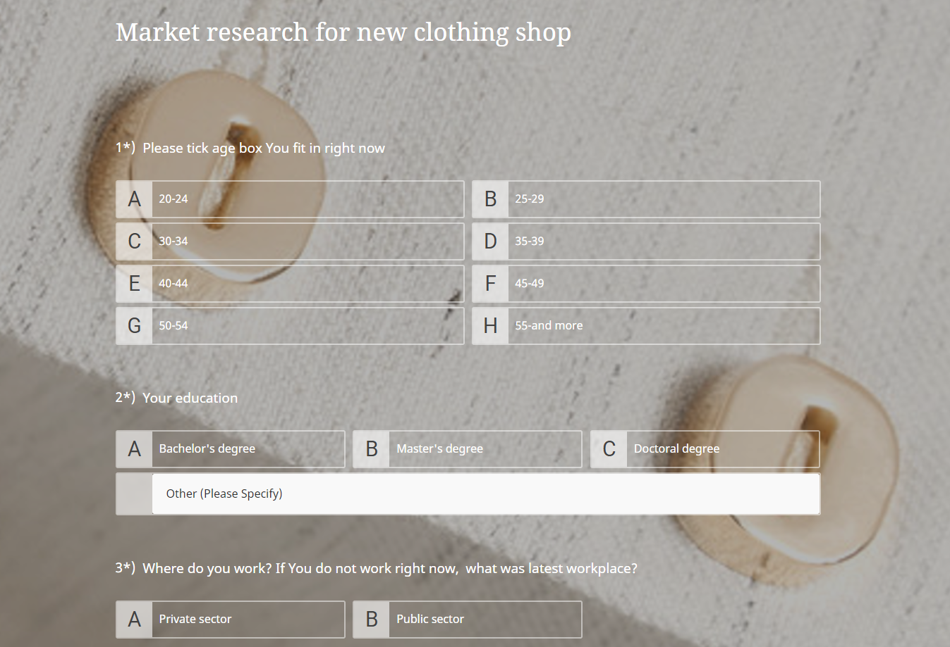

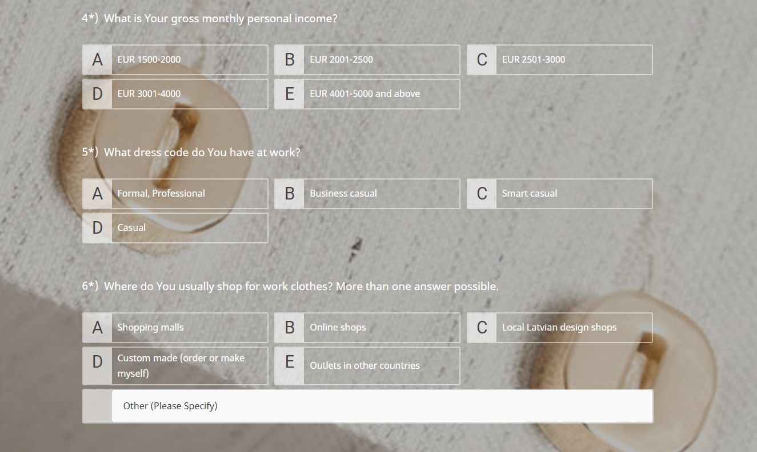

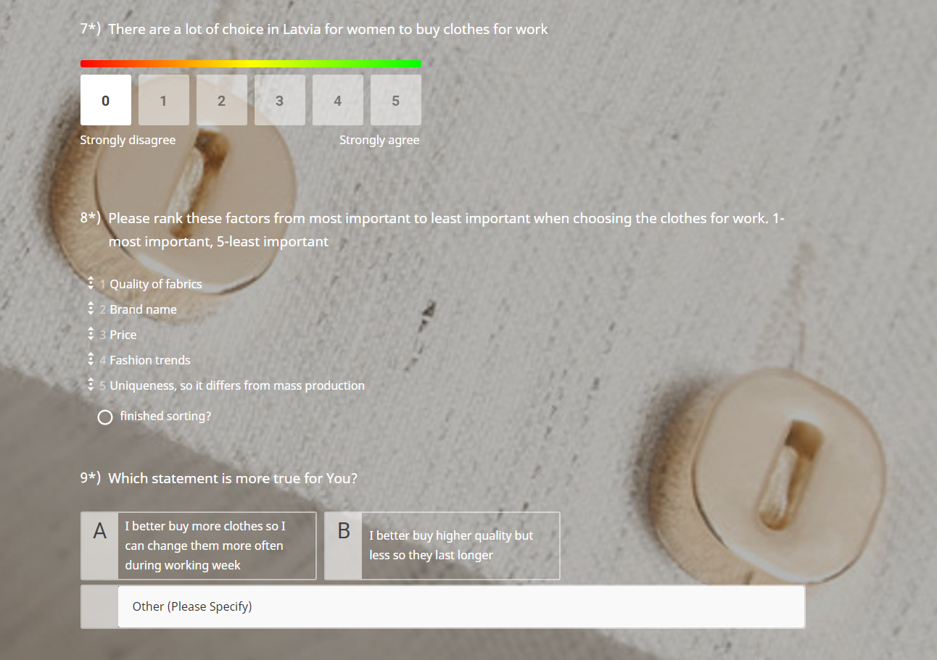

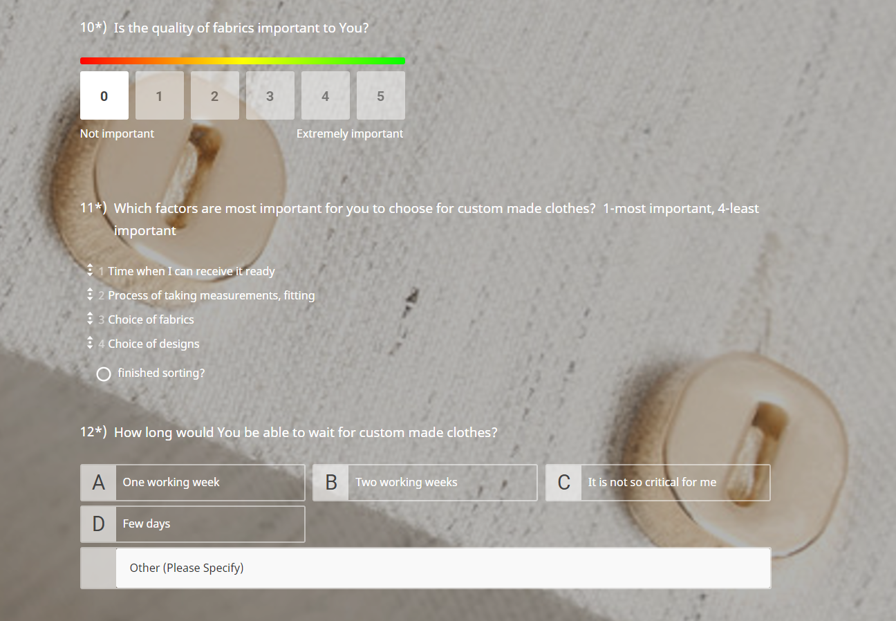

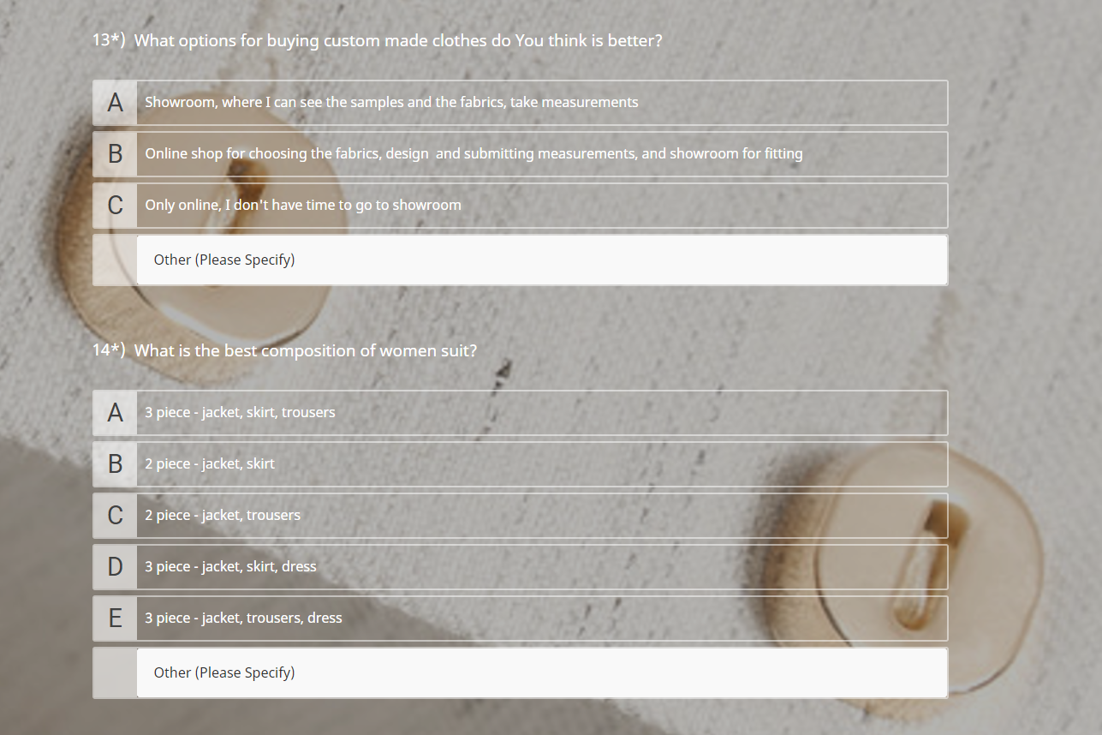

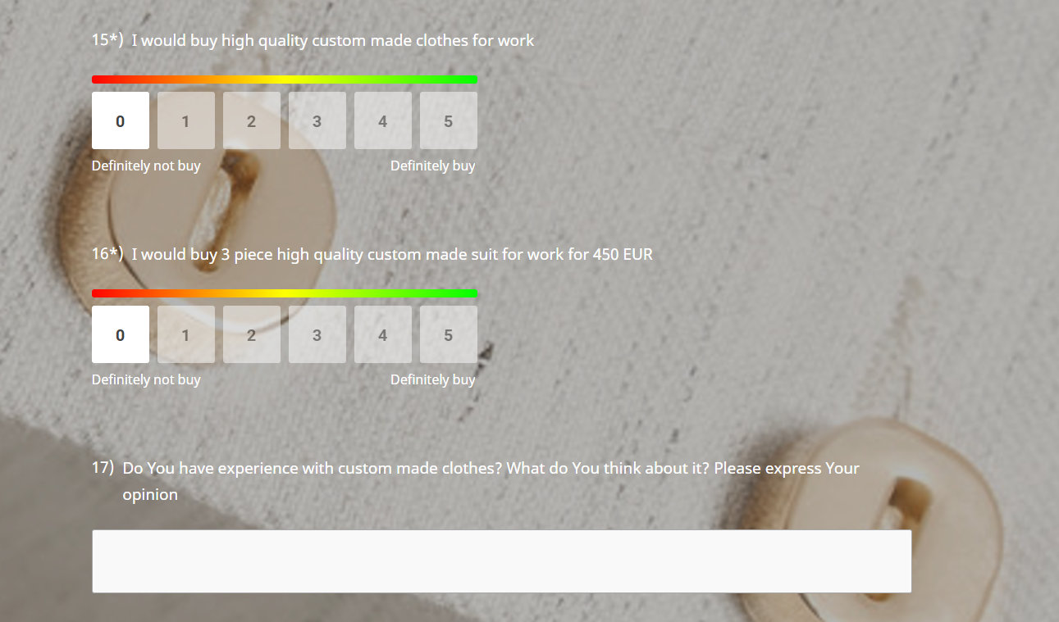

Appendix 3















Maģistra darbs aizstāvēts

valsts pārbaudījumu komisijas 2019. gada __________________sēdē

un novērtēts ar _________(______________________)

Protokola Nr. _______

Master thesis is defended at

State qualification committee meeting on _________________ 2019

and evaluated with the grade _________(______________________)

Minutes Nr. _______

Valsts pārbaudījumu komisijas priekšsēdētājs/ Chairman of State qualification committee

_______________ __________________

paraksts/ signature v.u. /name, surname

Šveices biznesa skolas pārstāvis/ SBS Swiss Business School representative

_______________ __________________

paraksts/ signature v.u. /name, surname

Valsts pārbaudījumu komisijas sekretārs/ Secretary of State qualification committee

_______________ __________________

paraksts/ signature v.u. /name, surname